R Notebook

John Kamau

21/08/2019

# Q6 Did the meeting start late?

|  |  |  |  |  |  |  |
| --- | --- | --- | --- | --- | --- | --- |
| Late | Mali_1 | Mali_2 | Mali_3 | Uganda_1 | Uganda_2 | Uganda_3 |
| Yes | 92 | 78 | 59 | 75 | 66 | 57 |
| No | 71 | 78 | 97 | 60 | 49 | 40 |
| Respondents | 163 | 156 | 156 | 135 | 115 | 97 |
| Late | Mali_1 | Mali_2 | Mali_3 | Uganda_1 | Uganda_2 | Uganda_3 |
| Yes | 0.56441717791411 | 0.5 | 0.378205128205128 | 0.555555555555556 | 0.573913043478261 | 0.587628865979381 |
| No | 0.43558282208589 | 0.5 | 0.621794871794872 | 0.444444444444444 | 0.426086956521739 | 0.412371134020619 |
| Percentage | 1 | 1 | 1 | 1 | 1 | 1 |

# Q7 How many minutes too late did the meeting start?

## [1] "G1"

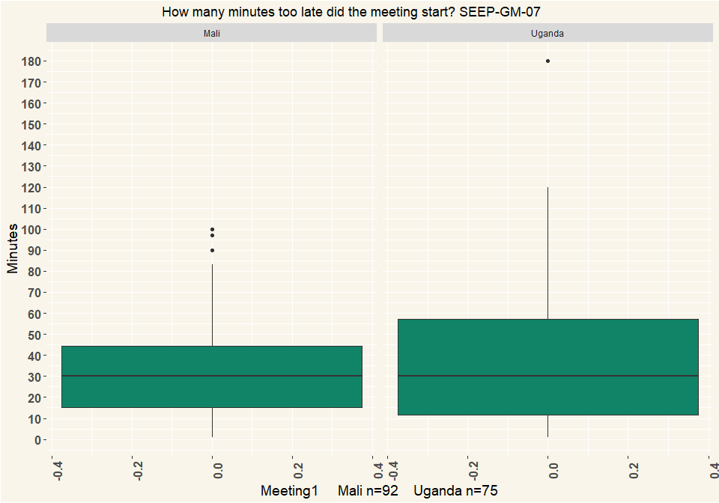

## [1] "G2"

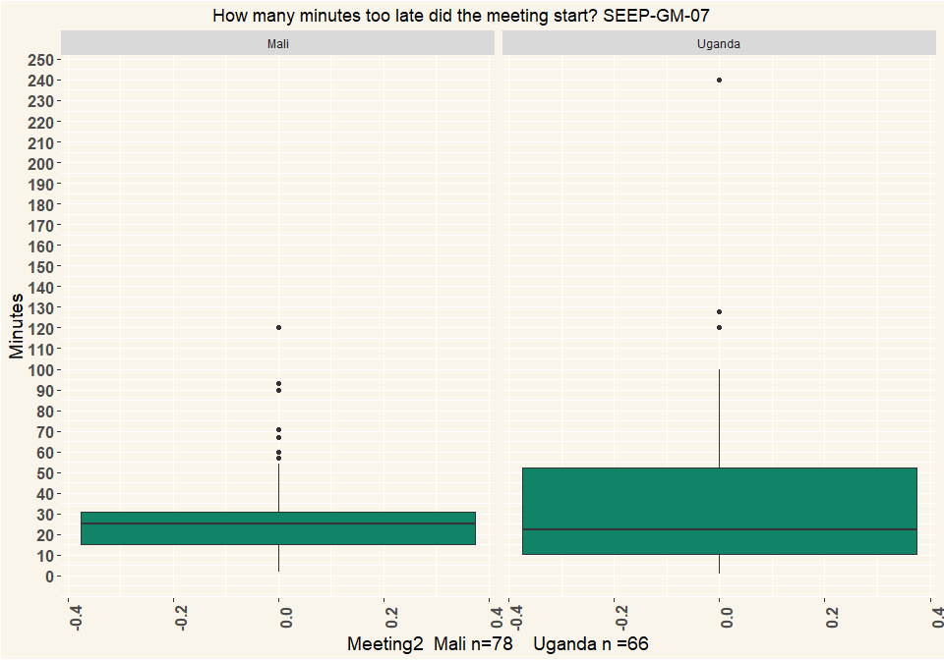

## [1] "G3"

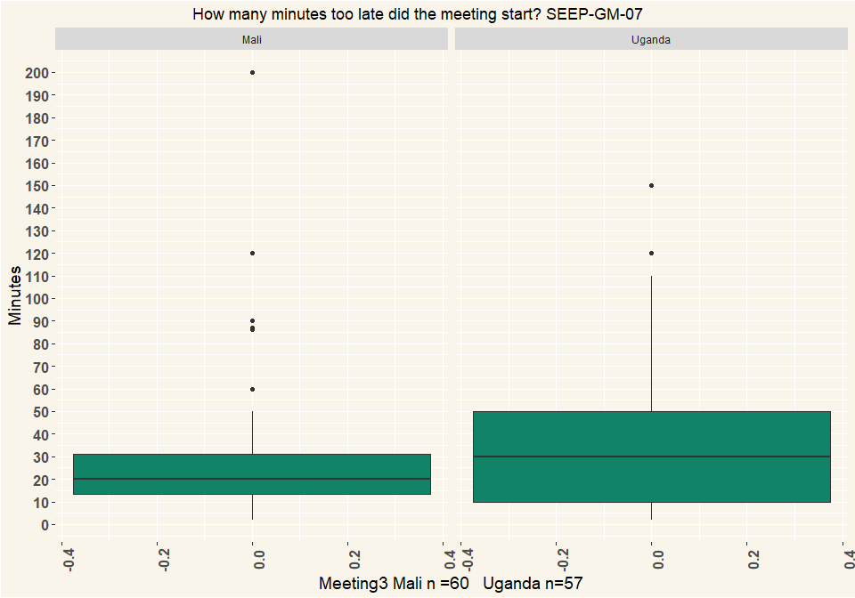

# Q8 What was the reason/were the reasons the meeting started late?

|  |  |  |  |  |  |  |
| --- | --- | --- | --- | --- | --- | --- |
| Late | Mali_G1 | Mali_G2 | Mali_G3 | Uganda_G1 | Uganda_G2 | Uganda_G3 |
| Chairperson or other committee members were late | 4 | 11 | 14 | 14 | 19 | 19 |
| Members were late | 74 | 63 | 54 | 56 | 46 | 40 |
| The location was not ready yet | 1 | 5 | 8 | 6 | 5 | 1 |
| People were first talking and discussing | 3 | 7 | 2 | 8 | 11 | 8 |
| Nobody paid attention to the time | 2 | 2 | NA | 11 | 9 | 5 |
| Other (specify) | 13 | 5 | 3 | 12 | 9 | 9 |
| Respondents | 97 | 93 | 81 | 107 | 99 | 82 |
| Late | Mali_G1 | Mali_G2 | Mali_G3 | Uganda_G1 | Uganda_G2 | Uganda_G3 |
| Chairperson or other committee members were late | 0.0412 | 0.118 | 0.173 | 0.131 | 0.192 | 0.232 |
| Members were late | 0.763 | 0.677 | 0.667 | 0.523 | 0.465 | 0.488 |
| The location was not ready yet | 0.0103 | 0.0538 | 0.0988 | 0.0561 | 0.0505 | 0.0122 |
| People were first talking and discussing | 0.0309 | 0.0753 | 0.0247 | 0.0748 | 0.111 | 0.0976 |
| Nobody paid attention to the time | 0.0206 | 0.0215 | NA | 0.103 | 0.0909 | 0.061 |
| Other (specify) | 0.134 | 0.0538 | 0.037 | 0.112 | 0.0909 | 0.11 |
| Percentage | 1 | 1 | 1 | 1 | 1 | 1 |

# Q9 Did the meeting start with a specific ritual, like a prayer, a song, a speech? (Multiple Choice)

|  |  |  |  |  |  |  |
| --- | --- | --- | --- | --- | --- | --- |
| Ritual | Mali_G1 | Mali_G2 | Mali_G3 | Uganda_G1 | Uganda_G2 | Uganda_G3 |
| A song or dance | 19 | 22 | 20 | NA | 1 | 1 |
| A prayer | 27 | 30 | 28 | 88 | 82 | 68 |
| A speech | 40 | 51 | 46 | 54 | 41 | 33 |
| Reciting group rules/constitution | 82 | 102 | 122 | 2 | NA | 1 |
| Other (specify) | 22 | 2 | 10 | 21 | 11 | 12 |
| Respondents | 190 | 207 | 226 | 165 | 135 | 115 |
| Ritual | Mali_G1 | Mali_G2 | Mali_G3 | Uganda_G1 | Uganda_G2 | Uganda_G3 |
| A song or dance | 0.1 | 0.106 | 0.0885 | NA | 0.00741 | 0.0087 |
| A prayer | 0.142 | 0.145 | 0.124 | 0.533 | 0.607 | 0.591 |
| A speech | 0.211 | 0.246 | 0.204 | 0.327 | 0.304 | 0.287 |
| Reciting group rules/constitution | 0.432 | 0.493 | 0.54 | 0.0121 | NA | 0.0087 |
| Other (specify) | 0.116 | 0.00966 | 0.0442 | 0.127 | 0.0815 | 0.104 |
| Percentage | 1 | 1 | 1 | 1 | 1 | 1 |

# Q10 Did the meeting have a round of questions or comment where each member got a chance to speak?

|  |  |  |  |  |  |  |
| --- | --- | --- | --- | --- | --- | --- |
| Questions | Mali_G1 | Mali_G2 | Mali_G3 | Uganda_G1 | Uganda_G2 | Uganda_G3 |
| Yes | 155 | 133 | 131 | 77 | 54 | 37 |
| No | 8 | 23 | 25 | 58 | 59 | 60 |
| Other (specify) | NA | NA | NA | NA | 1 | NA |
| I don’t know | NA | NA | NA | NA | 1 | NA |
| Respondents | 163 | 156 | 156 | 135 | 115 | 97 |
| Questions | Mali_G1 | Mali_G2 | Mali_G3 | Uganda_G1 | Uganda_G2 | Uganda_G3 |
| Yes | 0.951 | 0.853 | 0.84 | 0.57 | 0.47 | 0.381 |
| No | 0.0491 | 0.147 | 0.16 | 0.43 | 0.513 | 0.619 |
| Other (specify) | NA | NA | NA | NA | 0.0087 | NA |
| I don’t know | NA | NA | NA | NA | 0.0087 | NA |
| Percentage | 1 | 1 | 1 | 1 | 1 | 1 |

# Q11 How were the savings collected?

|  |  |  |  |  |  |  |
| --- | --- | --- | --- | --- | --- | --- |
| Savings | Mali_G1 | Mali_G2 | Mali_G3 | Uganda_G1 | Uganda_G2 | Uganda_G3 |
| One member was called at a time | 85 | 84 | 84 | 132 | 110 | 97 |
| All members put their savings at the same time | 40 | 48 | 49 | NA | 4 | NA |
| It was supposed to be one member at a time but it was chaotic and some doing at same time | NA | NA | NA | 3 | 1 | NA |
| Other (specify) | 38 | 24 | 23 | NA | NA | NA |
| Respondents | 163 | 156 | 156 | 135 | 115 | 97 |
| Savings | Mali_G1 | Mali_G2 | Mali_G3 | Uganda_G1 | Uganda_G2 | Uganda_G3 |
| One member was called at a time | 0.521 | 0.538 | 0.538 | 0.978 | 0.957 | 1 |
| All members put their savings at the same time | 0.245 | 0.308 | 0.314 | NA | 0.0348 | NA |
| It was supposed to be one member at a time but it was chaotic and some doing at same time | NA | NA | NA | 0.0222 | 0.0087 | NA |
| Other (specify) | 0.233 | 0.154 | 0.147 | NA | NA | NA |
| Percentage | 1 | 1 | 1 | 1 | 1 | 1 |

# Q12 Did each savings amount get counted?

|  |  |  |  |  |  |  |
| --- | --- | --- | --- | --- | --- | --- |
| Savings | Mali_G1 | Mali_G2 | Mali_G3 | Uganda_G1 | Uganda_G2 | Uganda_G3 |
| Yes, each savings amount got counted and the total was announced by a money counter | 151 | 150 | 150 | 117 | 110 | 95 |
| Yes, each savings amount got counted but total not announced | 10 | 3 | 3 | 16 | 4 | 2 |
| No, savings was not counted but put in view of others without counting | 2 | 2 | 3 | 2 | 1 | NA |
| No, savings was not counted and not in view of others | NA | 1 | NA | NA | NA | NA |
| Respondents | 163 | 156 | 156 | 135 | 115 | 97 |
| Savings | Mali_G1 | Mali_G2 | Mali_G3 | Uganda_G1 | Uganda_G2 | Uganda_G3 |
| Yes, each savings amount got counted and the total was announced by a money counter | 0.926 | 0.962 | 0.962 | 0.867 | 0.957 | 0.979 |
| Yes, each savings amount got counted but total not announced | 0.0613 | 0.0192 | 0.0192 | 0.119 | 0.0348 | 0.0206 |
| No, savings was not counted but put in view of others without counting | 0.0123 | 0.0128 | 0.0192 | 0.0148 | 0.0087 | NA |
| No, savings was not counted and not in view of others | NA | 0.00641 | NA | NA | NA | NA |
| Percentage | 1 | 1 | 1 | 1 | 1 | 1 |

# Q14 How were the savings recorded?

|  |  |  |  |  |  |  |
| --- | --- | --- | --- | --- | --- | --- |
| Savings | Mali_G1 | Mali_G2 | Mali_G3 | Uganda_G1 | Uganda_G2 | Uganda_G3 |
| Written record of each member’s savings | 105 | 122 | 88 | 130 | 110 | 91 |
| Some written system but only for total | 22 | 18 | 20 | 1 | 4 | 1 |
| Memory based system but only for total | 12 | 7 | 14 | NA | NA | 1 |
| Other (specify) | 16 | 8 | 13 | NA | NA | NA |
| Respondents | 155 | 155 | 135 | 131 | 114 | 93 |
| Savings | Mali_G1 | Mali_G2 | Mali_G3 | Uganda_G1 | Uganda_G2 | Uganda_G3 |
| Written record of each member’s savings | 0.677 | 0.787 | 0.652 | 0.992 | 0.965 | 0.978 |
| Some written system but only for total | 0.142 | 0.116 | 0.148 | 0.00763 | 0.0351 | 0.0108 |
| Memory based system but only for total | 0.0774 | 0.0452 | 0.104 | NA | NA | 0.0108 |
| Other (specify) | 0.103 | 0.0516 | 0.0963 | NA | NA | NA |
| Percentage | 1 | 1 | 1 | 1 | 1 | 1 |

# Q15 Do members have an individual pass-book?

|  |  |  |  |  |  |  |
| --- | --- | --- | --- | --- | --- | --- |
| Passbook | Mali_G1 | Mali_G2 | Mali_G3 | Uganda_G1 | Uganda_G2 | Uganda_G3 |
| Yes, and they keep it themselves and bring it to the meeting | 25 | 23 | 44 | 23 | 11 | 8 |
| Yes, but it is kept in the group | 3 | NA | NA | 95 | 87 | 76 |
| No, no passbooks | 135 | 133 | 112 | 15 | 14 | 11 |
| Other (specify) | NA | NA | NA | 2 | 3 | 2 |
| Respondents | 163 | 156 | 156 | 135 | 115 | 97 |
| Passbook | Mali_G1 | Mali_G2 | Mali_G3 | Uganda_G1 | Uganda_G2 | Uganda_G3 |
| Yes, and they keep it themselves and bring it to the meeting | 0.153 | 0.147 | 0.282 | 0.17 | 0.0957 | 0.0825 |
| Yes, but it is kept in the group | 0.0184 | NA | NA | 0.704 | 0.757 | 0.784 |
| No, no passbooks | 0.828 | 0.853 | 0.718 | 0.111 | 0.122 | 0.113 |
| Other (specify) | NA | NA | NA | 0.0148 | 0.0261 | 0.0206 |
| Percentage | 1 | 1 | 1 | 1 | 1 | 1 |

# Q16 Did the savings get recorded in the individual pass-books?

|  |  |  |  |  |  |  |
| --- | --- | --- | --- | --- | --- | --- |
| Passbook | Mali_G1 | Mali_G2 | Mali_G3 | Uganda_G1 | Uganda_G2 | Uganda_G3 |
| Yes, with stamps for each share bought | 1 | NA | 1 | 111 | 92 | 78 |
| Yes, with a pen indicating each share bought | 23 | 23 | 17 | 6 | 7 | 6 |
| Yes, amounts written out | 1 | NA | 5 | 1 | 1 | 2 |
| Other (specify) | 3 | NA | 22 | 2 | 2 | NA |
| Respondents | 28 | 23 | 45 | 120 | 102 | 86 |
| Passbook | Mali_G1 | Mali_G2 | Mali_G3 | Uganda_G1 | Uganda_G2 | Uganda_G3 |
| Yes, with stamps for each share bought | 0.0357 | NA | 0.0222 | 0.925 | 0.902 | 0.907 |
| Yes, with a pen indicating each share bought | 0.821 | 1 | 0.378 | 0.05 | 0.0686 | 0.0698 |
| Yes, amounts written out | 0.0357 | NA | 0.111 | 0.00833 | 0.0098 | 0.0233 |
| Other (specify) | 0.107 | NA | 0.489 | 0.0167 | 0.0196 | NA |
| Percentage | 1 | 1 | 1 | 1 | 1 | 1 |

# Q17 Did any of the group-members not save at all? How many did not save at all?

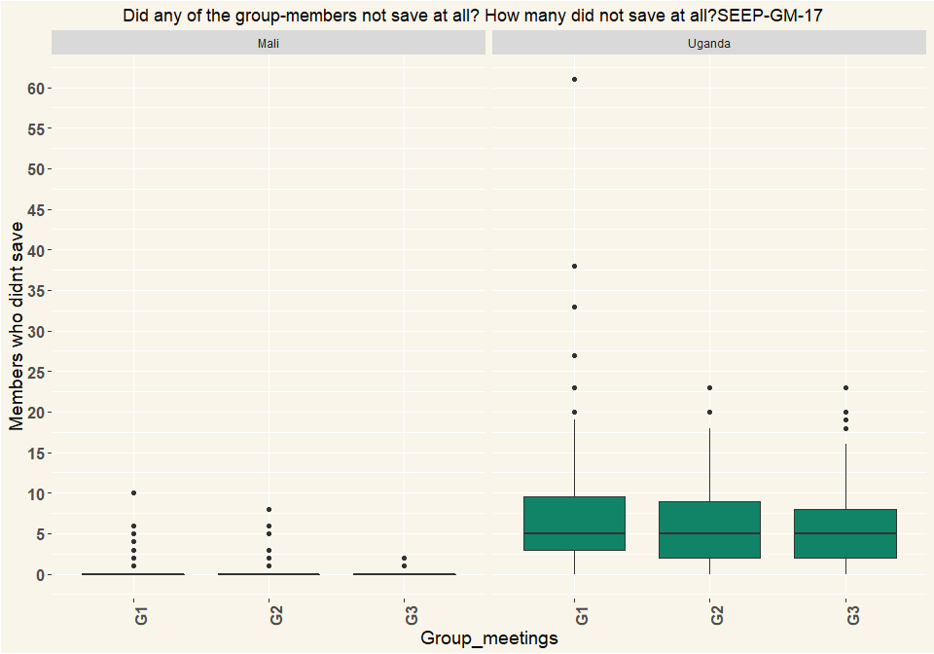

|  |  |  |  |
| --- | --- | --- | --- |
| Country | G1 | G2 | G3 |
| Mali | 163 | 156 | 156 |
| Uganda | 135 | 115 | 97 |

# Q18 Who did not save?

|  |  |  |  |  |  |  |
| --- | --- | --- | --- | --- | --- | --- |
| Non_savers | Mali_G1 | Mali_G2 | Mali_G3 | Uganda_G1 | Uganda_G2 | Uganda_G3 |
| People who were absent | 11 | 13 | 3 | 84 | 75 | 63 |
| People present | 3 | NA | 1 | NA | NA | 1 |
| Both absent and present people | 4 | 3 | 1 | 30 | 20 | 16 |
| Respondents | 18 | 16 | 5 | 114 | 95 | 80 |
| Non_savers | Mali_G1 | Mali_G2 | Mali_G3 | Uganda_G1 | Uganda_G2 | Uganda_G3 |
| People who were absent | 0.611 | 0.812 | 0.6 | 0.737 | 0.789 | 0.788 |
| People present | 0.167 | NA | 0.2 | NA | NA | 0.0125 |
| Both absent and present people | 0.222 | 0.188 | 0.2 | 0.263 | 0.211 | 0.2 |
| NA | 1 | 1 | 1 | 1 | 1 | 1 |

# Q19 Was it considered against the rules that some people did not save?

|  |  |  |  |  |  |  |
| --- | --- | --- | --- | --- | --- | --- |
| Non_savers | Mali_G1 | Mali_G2 | Mali_G3 | Uganda_G1 | Uganda_G2 | Uganda_G3 |
| Yes, very much | 13 | 12 | 7 | 24 | 24 | 15 |
| Yes, but no big deal made of it | 3 | NA | NA | 41 | 26 | 21 |
| No, did not seem to | 2 | 4 | NA | 39 | 43 | 43 |
| No, it was clearly according to the rules, it is allowed to miss savings | NA | NA | NA | 8 | 1 | NA |
| Other (specify) | NA | NA | NA | 2 | 1 | 1 |
| Respondents | 18 | 16 | 7 | 114 | 95 | 80 |
| Non_savers | Mali_G1 | Mali_G2 | Mali_G3 | Uganda_G1 | Uganda_G2 | Uganda_G3 |
| Yes, very much | 0.722 | 0.75 | 1 | 0.211 | 0.253 | 0.188 |
| Yes, but no big deal made of it | 0.167 | NA | NA | 0.36 | 0.274 | 0.262 |
| No, did not seem to | 0.111 | 0.25 | NA | 0.342 | 0.453 | 0.538 |
| No, it was clearly according to the rules, it is allowed to miss savings | NA | NA | NA | 0.0702 | 0.0105 | NA |
| Other (specify) | NA | NA | NA | 0.0175 | 0.0105 | 0.0125 |
| Percentage | 1 | 1 | 1 | 1 | 1 | 1 |

# Q20 Did the group give out loans at the meeting?

|  |  |  |  |  |  |  |
| --- | --- | --- | --- | --- | --- | --- |
| Loans | Mali_G1 | Mali_G2 | Mali_G3 | Uganda_G1 | Uganda_G2 | Uganda_G3 |
| Yes | 64 | 71 | 69 | 93 | 58 | 51 |
| No | 99 | 85 | 87 | 40 | 57 | 46 |
| Other (specify) | NA | NA | NA | 2 | NA | NA |
| Respondents | 163 | 156 | 156 | 135 | 115 | 97 |
| Loans | Mali_G1 | Mali_G2 | Mali_G3 | Uganda_G1 | Uganda_G2 | Uganda_G3 |
| Yes | 0.393 | 0.455 | 0.442 | 0.689 | 0.504 | 0.526 |
| No | 0.607 | 0.545 | 0.558 | 0.296 | 0.496 | 0.474 |
| Other (specify) | NA | NA | NA | 0.0148 | NA | NA |
| Percentage | 1 | 1 | 1 | 1 | 1 | 1 |

# Q22 Did people request loans or were they offered loans?

|  |  |  |  |  |  |  |
| --- | --- | --- | --- | --- | --- | --- |
| Loans | Mali_G1 | Mali_G2 | Mali_G3 | Uganda_G1 | Uganda_G2 | Uganda_G3 |
| Each member had the chance to request for a loan | 61 | 71 | 68 | 80 | 54 | 41 |
| Specific members were asked whether they wanted a loan | 2 | NA | 2 | 3 | 3 | 6 |
| Specific members were assigned to get a loan | 1 | NA | NA | 6 | 1 | 2 |
| Other (specify) | NA | NA | NA | 5 | 1 | 2 |
| Respondents | 64 | 71 | 70 | 94 | 59 | 51 |
| Loans | Mali_G1 | Mali_G2 | Mali_G3 | Uganda_G1 | Uganda_G2 | Uganda_G3 |
| Each member had the chance to request for a loan | 0.953 | 1 | 0.971 | 0.851 | 0.915 | 0.804 |
| Specific members were asked whether they wanted a loan | 0.0312 | NA | 0.0286 | 0.0319 | 0.0508 | 0.118 |
| Specific members were assigned to get a loan | 0.0156 | NA | NA | 0.0638 | 0.0169 | 0.0392 |
| Other (specify) | NA | NA | NA | 0.0532 | 0.0169 | 0.0392 |
| Percentage | 1 | 1 | 1 | 1 | 1 | 1 |

# Q23 How were the loan allocated?

|  |  |  |  |  |  |  |
| --- | --- | --- | --- | --- | --- | --- |
| Loans | Mali_G1 | Mali_G2 | Mali_G3 | Uganda_G1 | Uganda_G2 | Uganda_G3 |
| There were more applicants for loans than available loans, so only some were successful at getting a loan | 35 | 31 | 28 | 43 | 32 | 28 |
| All those requesting a loan received a loan | 28 | 40 | 41 | 46 | 25 | 22 |
| Loans were given (it was assumed all wanted a loan) | NA | NA | 1 | NA | NA | NA |
| Other (specify) | 1 | NA | NA | 5 | 2 | 1 |
| Respondents | 64 | 71 | 70 | 94 | 59 | 51 |
| Loans | Mali_G1 | Mali_G2 | Mali_G3 | Uganda_G1 | Uganda_G2 | Uganda_G3 |
| There were more applicants for loans than available loans, so only some were successful at getting a loan | 0.547 | 0.437 | 0.4 | 0.457 | 0.542 | 0.549 |
| All those requesting a loan received a loan | 0.438 | 0.563 | 0.586 | 0.489 | 0.424 | 0.431 |
| Loans were given (it was assumed all wanted a loan) | NA | NA | 0.0143 | NA | NA | NA |
| Other (specify) | 0.0156 | NA | NA | 0.0532 | 0.0339 | 0.0196 |
| Percentage | 1 | 1 | 1 | 1 | 1 | 1 |

# Q24 Did loan recipients need to meet financial criteria?

|  |  |  |  |  |  |  |
| --- | --- | --- | --- | --- | --- | --- |
| Loans | Mali_G1 | Mali_G2 | Mali_G3 | Uganda_G1 | Uganda_G2 | Uganda_G3 |
| Yes, record keeper verified that loans were within a specified multiple of member’s savings. | 27 | 21 | 18 | 64 | 44 | 31 |
| Yes, loan eligibility depended on previous repayment or other criteria | 13 | 9 | 15 | 23 | 8 | 10 |
| No, anyone could take a loan | 24 | 40 | 37 | 6 | 6 | 10 |
| Other(specify) | NA | 1 | NA | 1 | 1 | NA |
| Respondents | 64 | 71 | 70 | 94 | 59 | 51 |
| Loans | Mali_G1 | Mali_G2 | Mali_G3 | Uganda_G1 | Uganda_G2 | Uganda_G3 |
| Yes, record keeper verified that loans were within a specified multiple of member’s savings. | 0.422 | 0.296 | 0.257 | 0.681 | 0.746 | 0.608 |
| Yes, loan eligibility depended on previous repayment or other criteria | 0.203 | 0.127 | 0.214 | 0.245 | 0.136 | 0.196 |
| No, anyone could take a loan | 0.375 | 0.563 | 0.529 | 0.0638 | 0.102 | 0.196 |
| Other(specify) | NA | 0.0141 | NA | 0.0106 | 0.0169 | NA |
| Percentage | 1 | 1 | 1 | 1 | 1 | 1 |

# Q25 Were any rules about loan purpose applied or discussed?

|  |  |  |  |  |  |  |
| --- | --- | --- | --- | --- | --- | --- |
| Loans | Mali_G1 | Mali_G2 | Mali_G3 | Uganda_G1 | Uganda_G2 | Uganda_G3 |
| Yes, loan purpose had to be productive | 16 | 4 | 24 | 38 | 21 | 8 |
| Yes, loan purpose had to be useful (could be productive, emergencies, school fees…) | 23 | 28 | 24 | 9 | 2 | NA |
| loan purpose was mentioned but no criteria seemed required | 5 | 10 | 1 | 11 | 8 | 6 |
| Loan purpose was not discussed | 20 | 29 | 21 | 34 | 28 | 35 |
| Other (specify) | NA | NA | NA | 2 | NA | 2 |
| Respondents | 64 | 71 | 70 | 94 | 59 | 51 |
| Loans | Mali_G1 | Mali_G2 | Mali_G3 | Uganda_G1 | Uganda_G2 | Uganda_G3 |
| Yes, loan purpose had to be productive | 0.25 | 0.0563 | 0.343 | 0.404 | 0.356 | 0.157 |
| Yes, loan purpose had to be useful (could be productive, emergencies, school fees…) | 0.359 | 0.394 | 0.343 | 0.0957 | 0.0339 | NA |
| loan purpose was mentioned but no criteria seemed required | 0.0781 | 0.141 | 0.0143 | 0.117 | 0.136 | 0.118 |
| Loan purpose was not discussed | 0.312 | 0.408 | 0.3 | 0.362 | 0.475 | 0.686 |
| Other (specify) | NA | NA | NA | 0.0213 | NA | 0.0392 |
| Percentage | 1 | 1 | 1 | 1 | 1 | 1 |

# Q26 Who made the loan approval decision?

|  |  |  |  |  |  |  |
| --- | --- | --- | --- | --- | --- | --- |
| Loans | Mali_G1 | Mali_G2 | Mali_G3 | Uganda_G1 | Uganda_G2 | Uganda_G3 |
| The chairperson | 8 | 4 | 7 | 6 | 5 | 2 |
| The committee | 27 | 23 | 22 | 21 | 16 | 22 |
| The entire savings-group (voting) | 8 | 5 | 15 | 31 | 18 | 18 |
| Just by discussion, nobody decided | 6 | 15 | 8 | 24 | 13 | 7 |
| All requests automatically approved | 14 | 24 | 18 | 10 | 7 | 2 |
| Other (specify) | 1 | NA | NA | 2 | NA | NA |
| Respondents | 64 | 71 | 70 | 94 | 59 | 51 |
| Loans | Mali_G1 | Mali_G2 | Mali_G3 | Uganda_G1 | Uganda_G2 | Uganda_G3 |
| The chairperson | 0.125 | 0.0563 | 0.1 | 0.0638 | 0.0847 | 0.0392 |
| The committee | 0.422 | 0.324 | 0.314 | 0.223 | 0.271 | 0.431 |
| The entire savings-group (voting) | 0.125 | 0.0704 | 0.214 | 0.33 | 0.305 | 0.353 |
| Just by discussion, nobody decided | 0.0938 | 0.211 | 0.114 | 0.255 | 0.22 | 0.137 |
| All requests automatically approved | 0.219 | 0.338 | 0.257 | 0.106 | 0.119 | 0.0392 |
| Other (specify) | 0.0156 | NA | NA | 0.0213 | NA | NA |
| Percentage | 1 | 1 | 1 | 1 | 1 | 1 |

# Q27 What is the interest rate charged for loans given at the meeting?

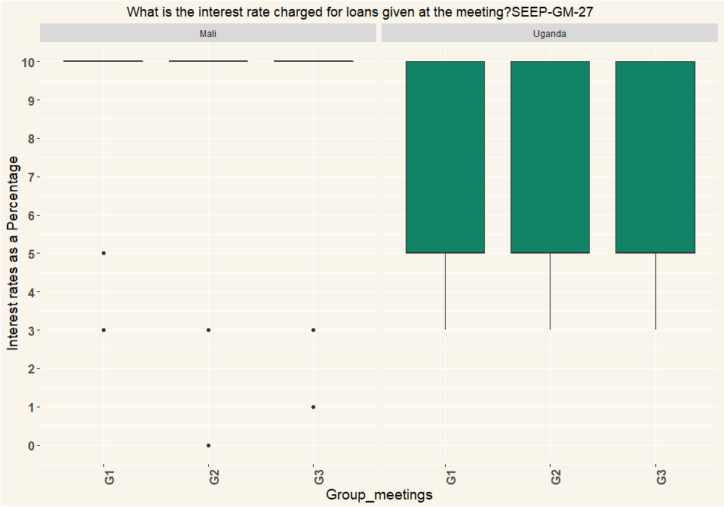

|  |  |  |  |
| --- | --- | --- | --- |
| Country | G1 | G2 | G3 |
| Mali | 64 | 71 | 70 |
| Uganda | 94 | 59 | 51 |

# Q28 how is that calculated?

|  |  |  |  |  |  |  |
| --- | --- | --- | --- | --- | --- | --- |
| Calculated | Mali_G1 | Mali_G2 | Mali_G3 | Uganda_G1 | Uganda_G2 | Uganda_G3 |
| One time, on amount borrowed. | 4 | 11 | 5 | 14 | 5 | 1 |
| Monthly, for period borrowed. | 57 | 58 | 64 | 52 | 30 | 25 |
| Recalculated each month on declining balance of loan | NA | 2 | 1 | 28 | 23 | 24 |
| Other: | 3 | NA | NA | NA | 1 | 1 |
| Respondents | 64 | 71 | 70 | 94 | 59 | 51 |
| Calculated | Mali_G1 | Mali_G2 | Mali_G3 | Uganda_G1 | Uganda_G2 | Uganda_G3 |
| One time, on amount borrowed. | 0.0625 | 0.155 | 0.0714 | 0.149 | 0.0847 | 0.0196 |
| Monthly, for period borrowed. | 0.891 | 0.817 | 0.914 | 0.553 | 0.508 | 0.49 |
| Recalculated each month on declining balance of loan | NA | 0.0282 | 0.0143 | 0.298 | 0.39 | 0.471 |
| Other: | 0.0469 | NA | NA | NA | 0.0169 | 0.0196 |
| Percentage | 1 | 1 | 1 | 1 | 1 | 1 |

# Q29 Did the group make any other decisions?

|  |  |  |  |  |  |  |
| --- | --- | --- | --- | --- | --- | --- |
| Decisions | Mali_G1 | Mali_G2 | Mali_G3 | Uganda_G1 | Uganda_G2 | Uganda_G3 |
| Allowing new members | 6 | 25 | 15 | 10 | 3 | 2 |
| Change rule(s) | 2 | 29 | 35 | 3 | 2 | 1 |
| Dealing with defaulted loans | 4 | 7 | 15 | 2 | NA | 1 |
| Dealing with members leaving | NA | NA | NA | 7 | 2 | 1 |
| New rules | 24 | 22 | 4 | 4 | 2 | 1 |
| no other decision | 127 | 108 | 111 | 111 | 108 | 92 |
| Other issues (specify) | 3 | 6 | NA | 3 | 2 | NA |
| Respondents | 166 | 197 | 180 | 140 | 119 | 98 |
| Decisions | Mali_G1 | Mali_G2 | Mali_G3 | Uganda_G1 | Uganda_G2 | Uganda_G3 |
| Allowing new members | 0.0361 | 0.127 | 0.0833 | 0.0714 | 0.0252 | 0.0204 |
| Change rule(s) | 0.012 | 0.147 | 0.194 | 0.0214 | 0.0168 | 0.0102 |
| Dealing with defaulted loans | 0.0241 | 0.0355 | 0.0833 | 0.0143 | NA | 0.0102 |
| Dealing with members leaving | NA | NA | NA | 0.05 | 0.0168 | 0.0102 |
| New rules | 0.145 | 0.112 | 0.0222 | 0.0286 | 0.0168 | 0.0102 |
| no other decision | 0.765 | 0.548 | 0.617 | 0.793 | 0.908 | 0.939 |
| Other issues (specify) | 0.0181 | 0.0305 | NA | 0.0214 | 0.0168 | NA |
| Percentage | 1 | 1 | 1 | 1 | 1 | 1 |

# Q31 Did the group have any conflict or disagreement in the meeting?

|  |  |  |  |  |  |  |
| --- | --- | --- | --- | --- | --- | --- |
| Conflict | Mali_G1 | Mali_G2 | Mali_G3 | Uganda_G1 | Uganda_G2 | Uganda_G3 |
| Yes, a large disagreement/conflict | 3 | NA | 1 | 2 | NA | NA |
| Yes, just small disagreements | 4 | 5 | NA | 17 | 4 | 3 |
| No, I did not notice anything | 133 | 137 | 155 | 115 | 110 | 93 |
| Other (specify) | 23 | 14 | NA | 1 | 1 | 1 |
| Respondents | 163 | 156 | 156 | 135 | 115 | 97 |
| Conflict | Mali_G1 | Mali_G2 | Mali_G3 | Uganda_G1 | Uganda_G2 | Uganda_G3 |
| Yes, a large disagreement/conflict | 0.0184 | NA | 0.00641 | 0.0148 | NA | NA |
| Yes, just small disagreements | 0.0245 | 0.0321 | NA | 0.126 | 0.0348 | 0.0309 |
| No, I did not notice anything | 0.816 | 0.878 | 0.994 | 0.852 | 0.957 | 0.959 |
| Other (specify) | 0.141 | 0.0897 | NA | 0.00741 | 0.0087 | 0.0103 |
| Percentage | 1 | 1 | 1 | 1 | 1 | 1 |

# Q32 Was the conflict or disagreement resolved?

|  |  |  |  |  |  |  |
| --- | --- | --- | --- | --- | --- | --- |
| Conflict | Mali_G1 | Mali_G2 | Mali_G3 | Uganda_G1 | Uganda_G2 | Uganda_G3 |
| Yes | 8 | 3 | NA | 16 | 3 | 1 |
| More or less | NA | 2 | 3 | 2 | 1 | 2 |
| No | NA | NA | NA | 1 | NA | NA |
| Respondents | 8 | 5 | 3 | 19 | 4 | 3 |
| Conflict | Mali_G1 | Mali_G2 | Mali_G3 | Uganda_G1 | Uganda_G2 | Uganda_G3 |
| Yes | 1 | 0.6 | NA | 0.842 | 0.75 | 0.333 |
| More or less | NA | 0.4 | 1 | 0.105 | 0.25 | 0.667 |
| No | NA | NA | NA | 0.0526 | NA | NA |
| Percentage | 1 | 1 | 1 | 1 | 1 | 1 |

# Q35 At the end of the meeting, how many members had outstanding loans?

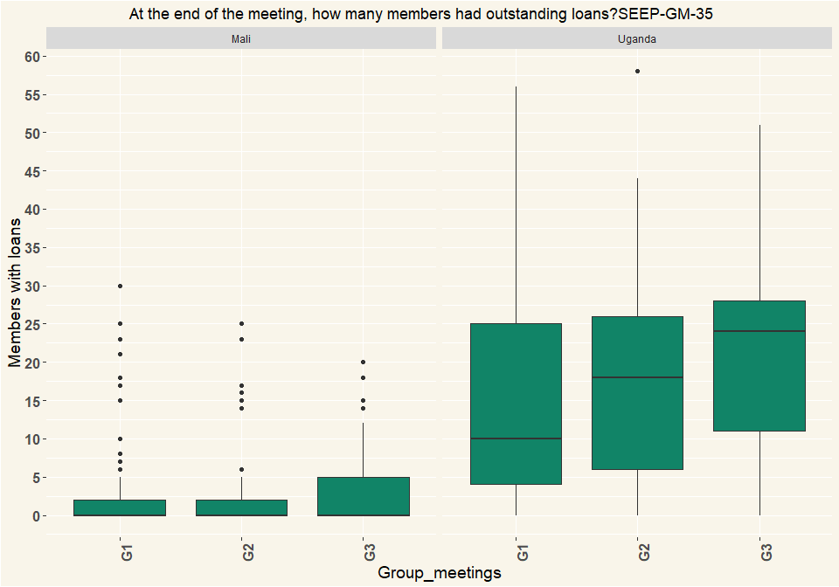

|  |  |  |  |
| --- | --- | --- | --- |
| Country | G1 | G2 | G3 |
| Mali | 163 | 156 | 156 |
| Uganda | 135 | 115 | 97 |

# Q36 Does the group have a social fund?

|  |  |  |  |  |  |  |
| --- | --- | --- | --- | --- | --- | --- |
| Fund | Mali_G1 | Mali_G2 | Mali_G3 | Uganda_G1 | Uganda_G2 | Uganda_G3 |
| Yes | 8 | 2 | NA | 106 | 92 | 82 |
| No | 155 | 154 | 156 | 29 | 23 | 15 |
| Respondents | 163 | 156 | 156 | 135 | 115 | 97 |
| Fund | Mali_G1 | Mali_G2 | Mali_G3 | Uganda_G1 | Uganda_G2 | Uganda_G3 |
| Yes | 0.0491 | 0.0128 | NA | 0.785 | 0.8 | 0.845 |
| No | 0.951 | 0.987 | 1 | 0.215 | 0.2 | 0.155 |
| Percentage | 1 | 1 | 1 | 1 | 1 | 1 |

# Q37 How is it funded?

|  |  |  |  |  |  |  |
| --- | --- | --- | --- | --- | --- | --- |
| Fund | Mali_G1 | Mali_G2 | Mali_G3 | Uganda_G1 | Uganda_G2 | Uganda_G3 |
| Members contribute a fixed amount every meeting | 3 | 2 | 2 | 87 | 76 | 62 |
| Members contribute up to a certain amount then contributions are frozen until it drops below that amount. | NA | NA | NA | 10 | 6 | 10 |
| Other: | 5 | NA | NA | 9 | 11 | 10 |
| Respondents | 8 | 2 | 2 | 106 | 93 | 82 |
| Fund | Mali_G1 | Mali_G2 | Mali_G3 | Uganda_G1 | Uganda_G2 | Uganda_G3 |
| Members contribute a fixed amount every meeting | 0.375 | 1 | 1 | 0.821 | 0.817 | 0.756 |
| Members contribute up to a certain amount then contributions are frozen until it drops below that amount. | NA | NA | NA | 0.0943 | 0.0645 | 0.122 |
| Other: | 0.625 | NA | NA | 0.0849 | 0.118 | 0.122 |
| Percentage | 1 | 1 | 1 | 1 | 1 | 1 |

# Q38 What are the conditions to access the social fund?

|  |  |  |  |  |  |  |
| --- | --- | --- | --- | --- | --- | --- |
| Fund | Mali_G1 | Mali_G2 | Mali_G3 | Uganda_G1 | Uganda_G2 | Uganda_G3 |
| Members borrow with interest | 2 | NA | 1 | 2 | 1 | 1 |
| Members borrow without interest | 1 | NA | 1 | 99 | 85 | 78 |
| Members are given gifts that are not repaid | 5 | 1 | NA | 3 | 2 | 2 |
| Other: | NA | 1 | NA | 2 | 5 | 1 |
| Respondents | 8 | 2 | 2 | 106 | 93 | 82 |
| Fund | Mali_G1 | Mali_G2 | Mali_G3 | Uganda_G1 | Uganda_G2 | Uganda_G3 |
| Members borrow with interest | 0.25 | NA | 0.5 | 0.0189 | 0.0108 | 0.0122 |
| Members borrow without interest | 0.125 | NA | 0.5 | 0.934 | 0.914 | 0.951 |
| Members are given gifts that are not repaid | 0.625 | 0.5 | NA | 0.0283 | 0.0215 | 0.0244 |
| Other: | NA | 0.5 | NA | 0.0189 | 0.0538 | 0.0122 |
| Percentage | 1 | 1 | 1 | 1 | 1 | 1 |

# Q39 What are the criteria for receiving social fund money?

|  |  |  |  |  |  |  |
| --- | --- | --- | --- | --- | --- | --- |
| Fund | Mali_G1 | Mali_G2 | Mali_G3 | Uganda_G1 | Uganda_G2 | Uganda_G3 |
| Specific list of uses only (such as death, birth, injury) | 5 | 1 | 2 | 32 | 23 | 27 |
| Request money for any social need | 3 | NA | NA | 70 | 69 | 54 |
| Other (specify) | NA | 1 | NA | 4 | 1 | 1 |
| Respondents | 8 | 2 | 2 | 106 | 93 | 82 |
| Fund | Mali_G1 | Mali_G2 | Mali_G3 | Uganda_G1 | Uganda_G2 | Uganda_G3 |
| Specific list of uses only (such as death, birth, injury) | 0.625 | 0.5 | 1 | 0.302 | 0.247 | 0.329 |
| Request money for any social need | 0.375 | NA | NA | 0.66 | 0.742 | 0.659 |
| Other (specify) | NA | 0.5 | NA | 0.0377 | 0.0108 | 0.0122 |
| Percentage | 1 | 1 | 1 | 1 | 1 | 1 |

# Q40 What is the balance of the Social Fund?

* Mali exchange rate 0.00169950
* Uganda exchange rate 0.000270226

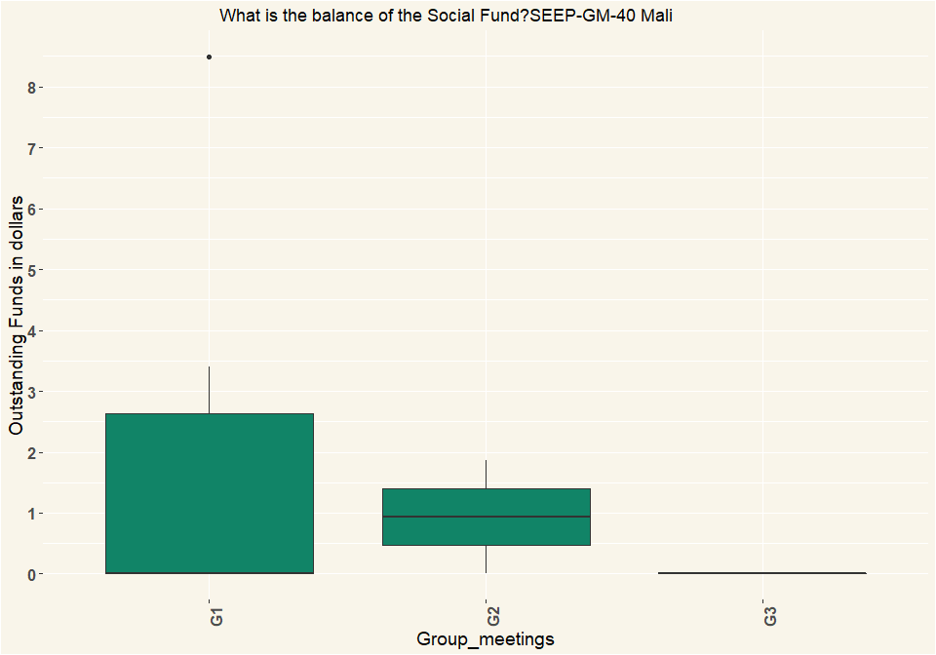

## [1] "Uganda"

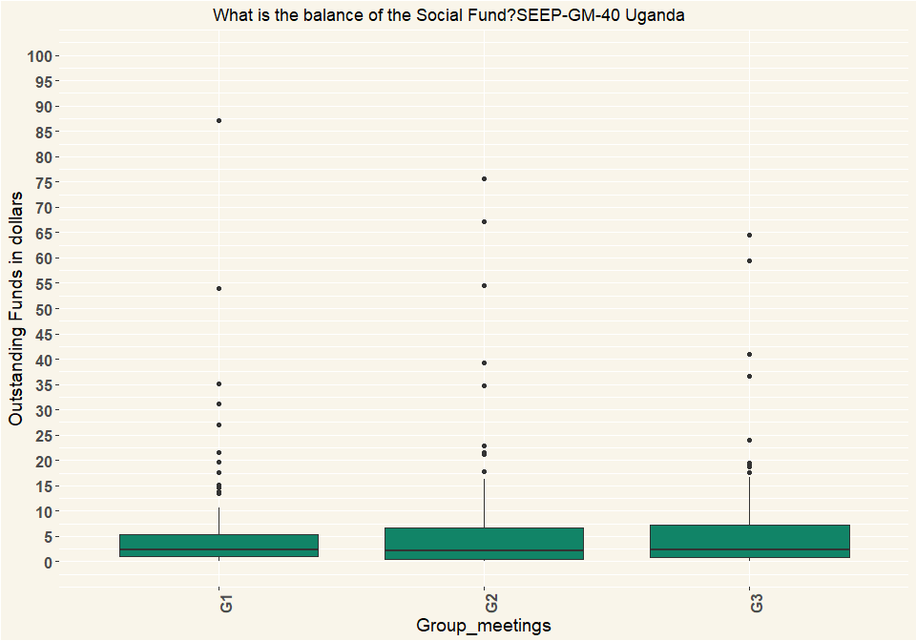

|  |  |  |  |
| --- | --- | --- | --- |
| Country | G1 | G2 | G3 |
| Mali | 8 | 2 | 2 |
| Uganda | 106 | 93 | 82 |

# Q41 Did any elections take place or get discussed for committee positions?

|  |  |  |  |  |  |  |
| --- | --- | --- | --- | --- | --- | --- |
| Elections | Mali_G1 | Mali_G2 | Mali_G3 | Uganda_G1 | Uganda_G2 | Uganda_G3 |
| No, not mentioned | 159 | 155 | 156 | 133 | 114 | 97 |
| Yes, discussed but planned for later | 2 | NA | NA | 1 | NA | NA |
| Yes, elections took place | 2 | 1 | NA | 1 | 1 | NA |
| Respondents | 163 | 156 | 156 | 135 | 115 | 97 |
| Elections | Mali_G1 | Mali_G2 | Mali_G3 | Uganda_G1 | Uganda_G2 | Uganda_G3 |
| No, not mentioned | 0.975 | 0.994 | 1 | 0.985 | 0.991 | 1 |
| Yes, discussed but planned for later | 0.0123 | NA | NA | 0.00741 | NA | NA |
| Yes, elections took place | 0.0123 | 0.00641 | NA | 0.00741 | 0.0087 | NA |
| Percentage | 1 | 1 | 1 | 1 | 1 | 1 |

# Q44 How was the cash handled?

|  |  |  |  |  |  |  |
| --- | --- | --- | --- | --- | --- | --- |
| Cash | Mali_G1 | Mali_G2 | Mali_G3 | Uganda_G1 | Uganda_G2 | Uganda_G3 |
| Separate money counter/ separate bookkeeper/ separate treasurer, | 62 | 77 | 98 | 106 | 111 | 89 |
| Separate bookkeeper / treasurer | 91 | 76 | 58 | 24 | 2 | 5 |
| All done by same person | 10 | 3 | NA | 5 | 2 | 3 |
| Respondents | 163 | 156 | 156 | 135 | 115 | 97 |
| Cash | Mali_G1 | Mali_G2 | Mali_G3 | Uganda_G1 | Uganda_G2 | Uganda_G3 |
| Separate money counter/ separate bookkeeper/ separate treasurer, | 0.38 | 0.494 | 0.628 | 0.785 | 0.965 | 0.918 |
| Separate bookkeeper / treasurer | 0.558 | 0.487 | 0.372 | 0.178 | 0.0174 | 0.0515 |
| All done by same person | 0.0613 | 0.0192 | NA | 0.037 | 0.0174 | 0.0309 |
| Percentage | 1 | 1 | 1 | 1 | 1 | 1 |

# Q45 Where was the cash money stored between previous and this meeting?

|  |  |  |  |  |  |  |
| --- | --- | --- | --- | --- | --- | --- |
| Cash | Mali_G1 | Mali_G2 | Mali_G3 | Uganda_G1 | Uganda_G2 | Uganda_G3 |
| In a box with several locks | 5 | 1 | 1 | 119 | 89 | 66 |
| In a box with 1 lock | 155 | 153 | 154 | 2 | NA | NA |
| In another container that could be locked | NA | 1 | 1 | NA | NA | NA |
| In another container locked with one lock | NA | NA | NA | 4 | 13 | 15 |
| No money was left (all lent out) | NA | NA | NA | 6 | 9 | 14 |
| Other (specify) | 2 | NA | NA | 4 | 4 | 2 |
| Respondents | 162 | 155 | 156 | 135 | 115 | 97 |
| Cash | Mali_G1 | Mali_G2 | Mali_G3 | Uganda_G1 | Uganda_G2 | Uganda_G3 |
| In a box with several locks | 0.0309 | 0.00645 | 0.00641 | 0.881 | 0.774 | 0.68 |
| In a box with 1 lock | 0.957 | 0.987 | 0.987 | 0.0148 | NA | NA |
| In another container that could be locked | NA | 0.00645 | 0.00641 | NA | NA | NA |
| In another container locked with one lock | NA | NA | NA | 0.0296 | 0.113 | 0.155 |
| No money was left (all lent out) | NA | NA | NA | 0.0444 | 0.0783 | 0.144 |
| Other (specify) | 0.0123 | NA | NA | 0.0296 | 0.0348 | 0.0206 |
| Percentage | 1 | 1 | 1 | 1 | 1 | 1 |

# Q46 Did any of the money from the group get stored in a (bank-)account or mobile money account between last and this meeting?

|  |  |  |  |  |  |  |
| --- | --- | --- | --- | --- | --- | --- |
| Cash | Mali_G1 | Mali_G2 | Mali_G3 | Uganda_G1 | Uganda_G2 | Uganda_G3 |
| Yes, all excess cash was stored in the account | 23 | 25 | 24 | 7 | 8 | 4 |
| Yes, some excess cash was stored in the account | 1 | NA | 1 | 3 | 4 | NA |
| No, the excess cash was too little | 31 | 27 | 24 | 24 | 19 | 11 |
| No, it was not considered | 101 | 104 | 107 | 84 | 80 | 76 |
| Other (specify) | 6 | NA | NA | 14 | 2 | 2 |
| I don’t know | 1 | NA | NA | 3 | 2 | 4 |
| Respondents | 163 | 156 | 156 | 135 | 115 | 97 |
| Cash | Mali_G1 | Mali_G2 | Mali_G3 | Uganda_G1 | Uganda_G2 | Uganda_G3 |
| Yes, all excess cash was stored in the account | 0.141 | 0.16 | 0.154 | 0.0519 | 0.0696 | 0.0412 |
| Yes, some excess cash was stored in the account | 0.00613 | NA | 0.00641 | 0.0222 | 0.0348 | NA |
| No, the excess cash was too little | 0.19 | 0.173 | 0.154 | 0.178 | 0.165 | 0.113 |
| No, it was not considered | 0.62 | 0.667 | 0.686 | 0.622 | 0.696 | 0.784 |
| Other (specify) | 0.0368 | NA | NA | 0.104 | 0.0174 | 0.0206 |
| I don’t know | 0.00613 | NA | NA | 0.0222 | 0.0174 | 0.0412 |
| Percentage | 1 | 1 | 1 | 1 | 1 | 1 |

# Q47 Did any of the money from the group get stored in different places, e.g. different group members?

|  |  |  |  |  |  |  |
| --- | --- | --- | --- | --- | --- | --- |
| Cash | Mali_G1 | Mali_G2 | Mali_G3 | Uganda_G1 | Uganda_G2 | Uganda_G3 |
| All in one place | 135 | 133 | 133 | 120 | 104 | 84 |
| In two places | 27 | 23 | 23 | 8 | 8 | 7 |
| Other (specify) | 1 | NA | NA | 4 | 3 | 2 |
| I don’t know | NA | NA | NA | 3 | NA | 4 |
| Respondents | 163 | 156 | 156 | 135 | 115 | 97 |
| Cash | Mali_G1 | Mali_G2 | Mali_G3 | Uganda_G1 | Uganda_G2 | Uganda_G3 |
| All in one place | 0.828 | 0.853 | 0.853 | 0.889 | 0.904 | 0.866 |
| In two places | 0.166 | 0.147 | 0.147 | 0.0593 | 0.0696 | 0.0722 |
| Other (specify) | 0.00613 | NA | NA | 0.0296 | 0.0261 | 0.0206 |
| I don’t know | NA | NA | NA | 0.0222 | NA | 0.0412 |
| Percentage | 1 | 1 | 1 | 1 | 1 | 1 |

# Q48 How many members attended in total?

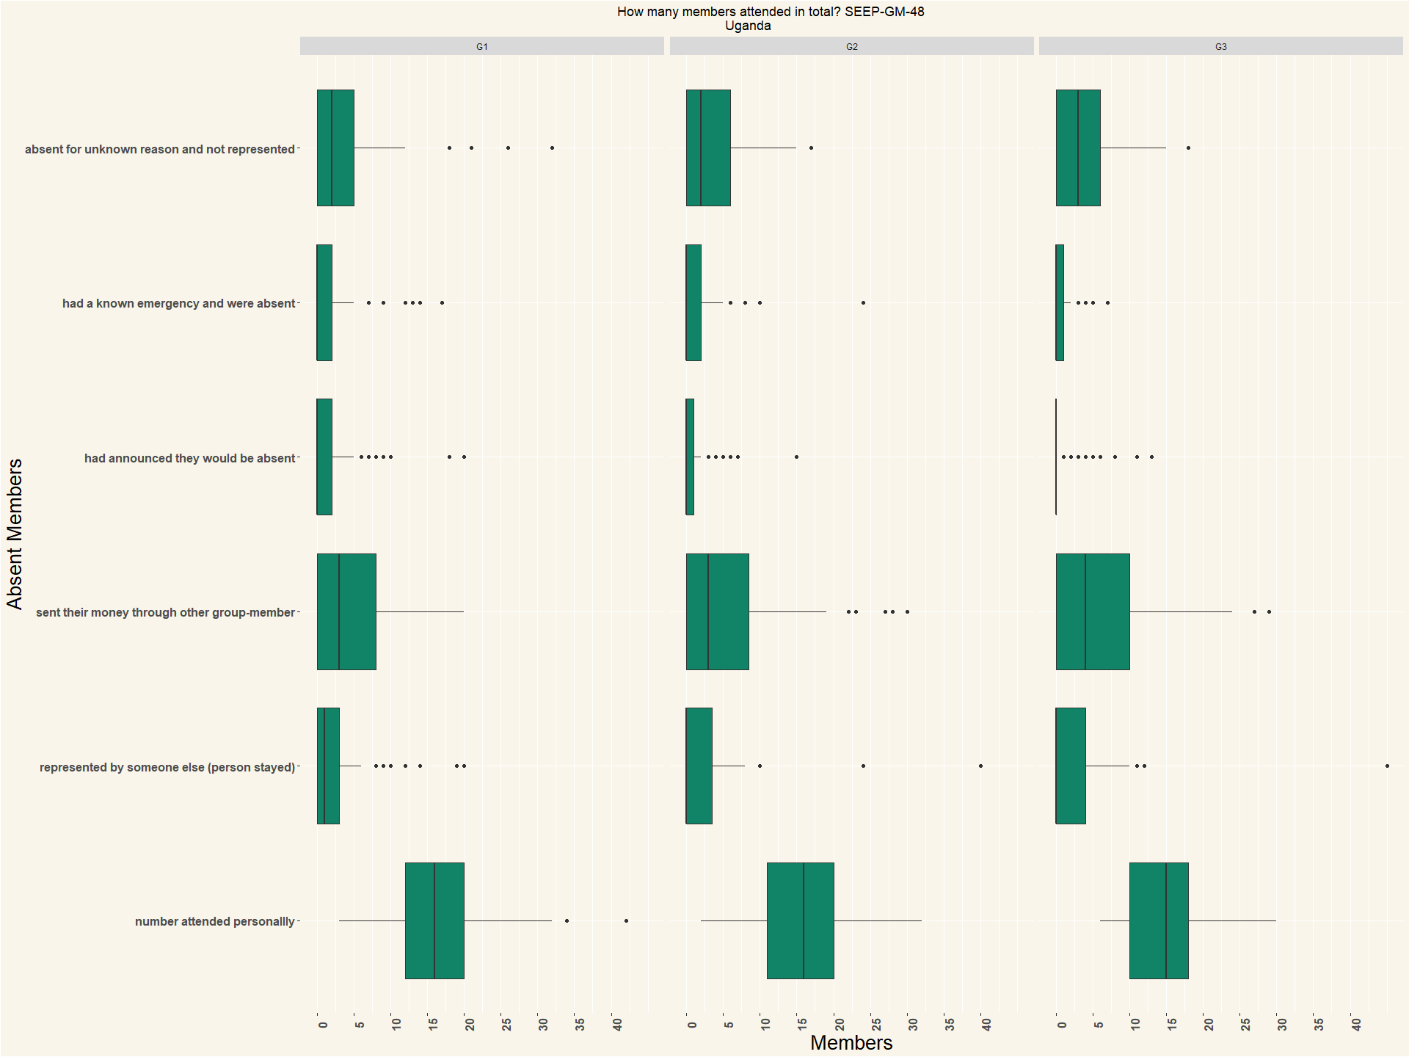

## [1] "Mali"

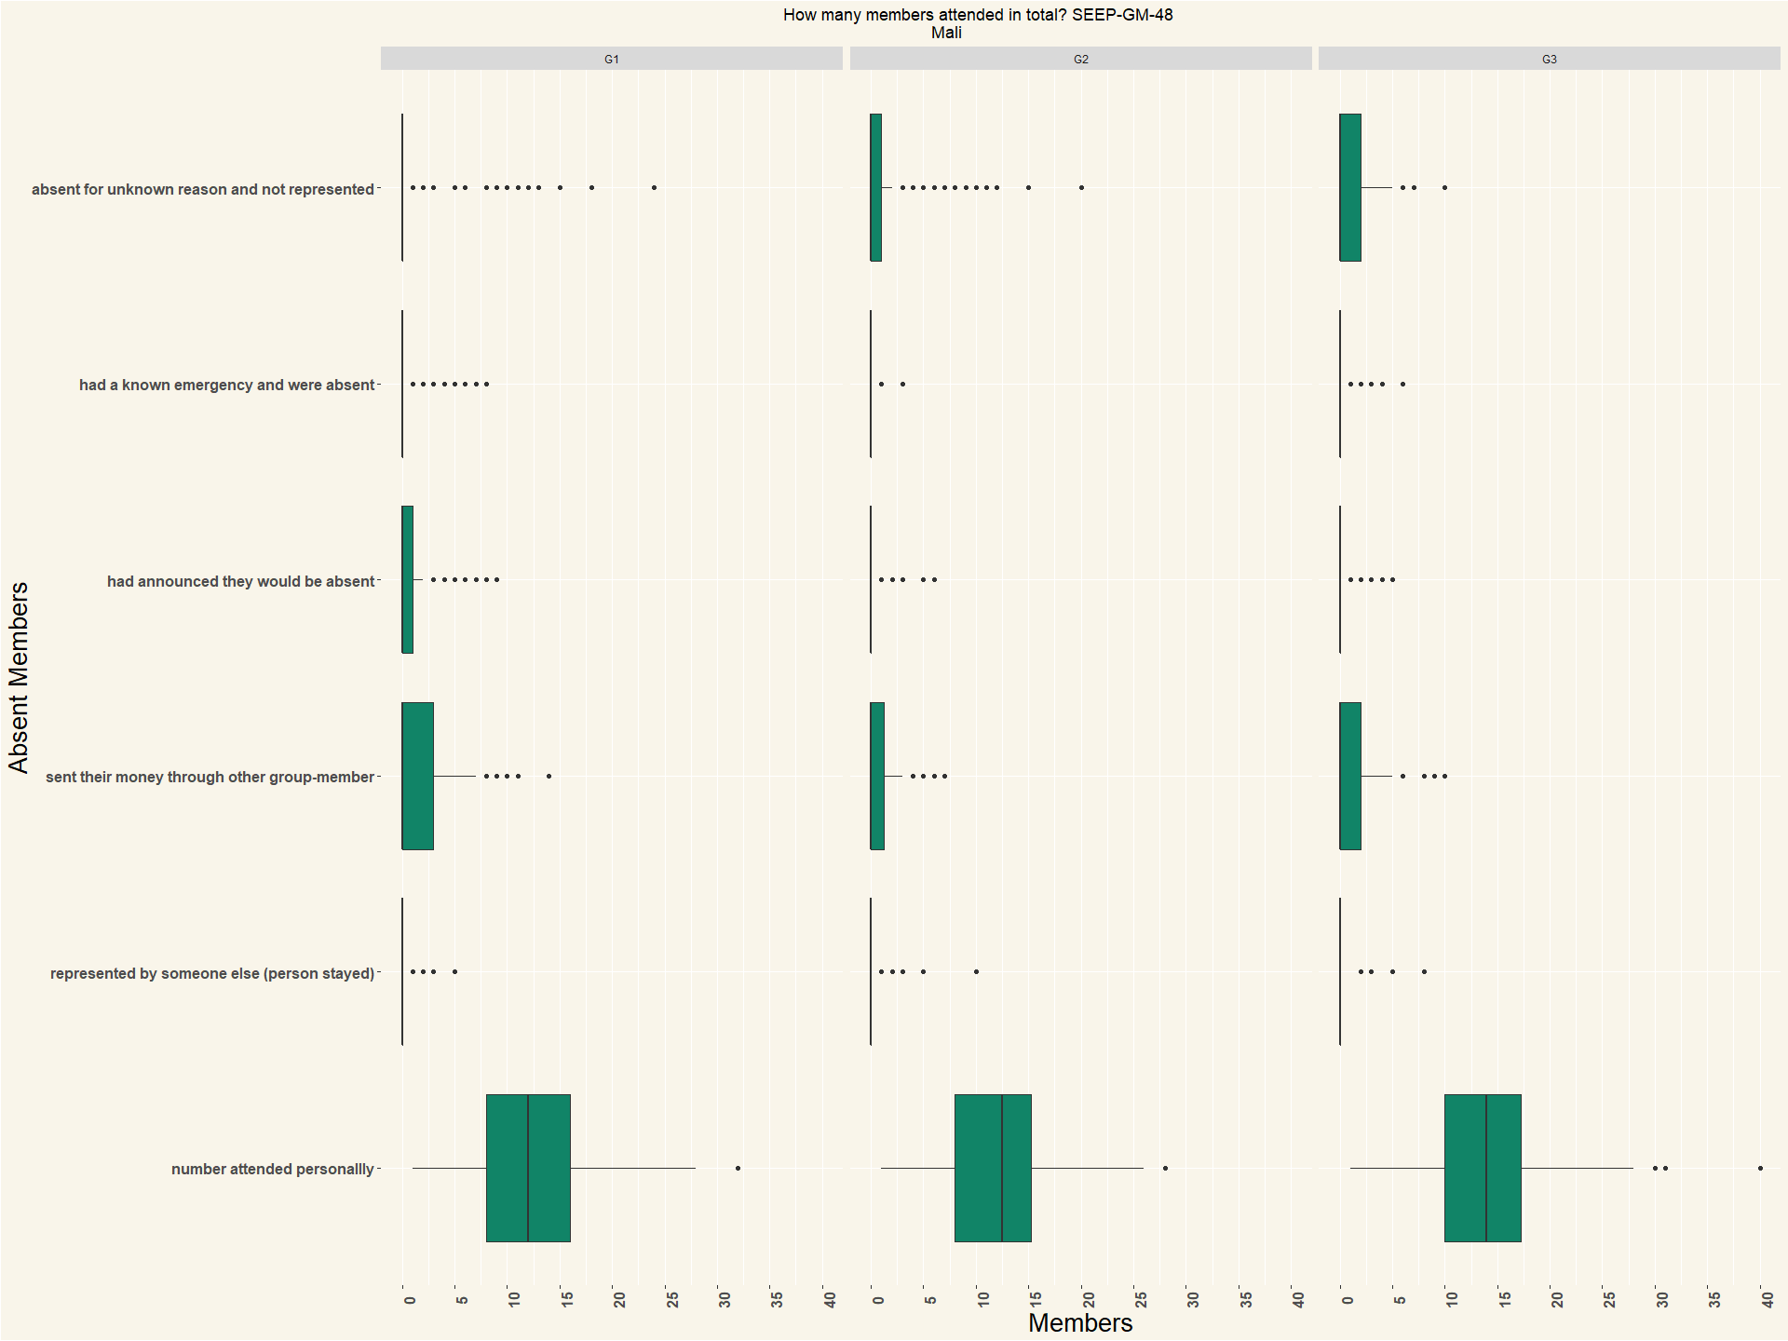

|  |  |  |  |
| --- | --- | --- | --- |
| Country | G1 | G2 | G3 |
| Mali | 163 | 156 | 156 |
| Uganda | 135 | 115 | 97 |

# Q49 How many members arrived after meeting started?

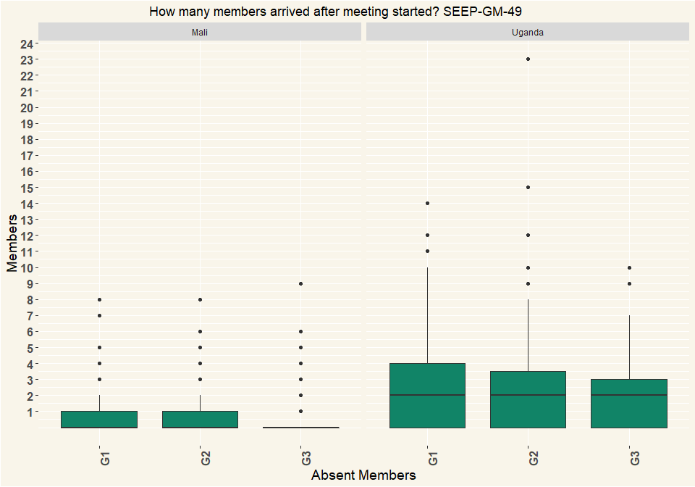

|  |  |  |  |
| --- | --- | --- | --- |
| Country | G1 | G2 | G3 |
| Mali | 163 | 156 | 156 |
| Uganda | 135 | 115 | 97 |

# Q50 Has the group experienced any of the following since last meeting up to end of this meeting?

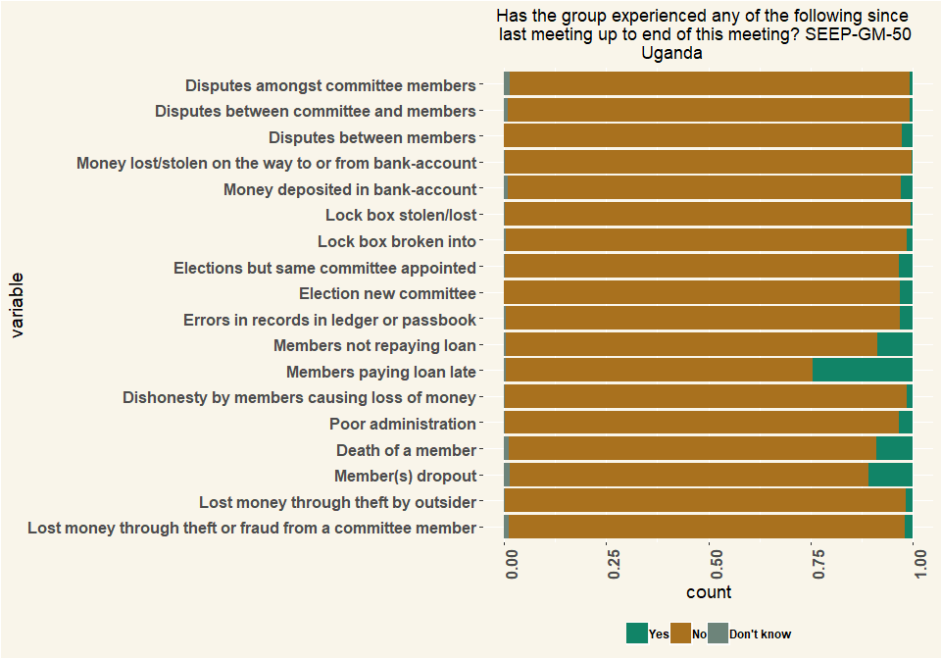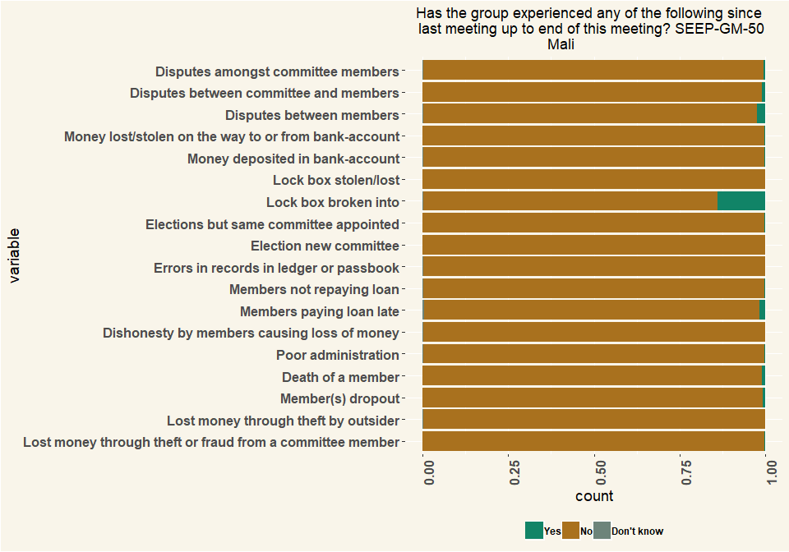

|  |  |  |  |
| --- | --- | --- | --- |
| Country | G1 | G2 | G3 |
| Mali | 163 | 156 | 156 |
| Uganda | 135 | 115 | 97 |

# Q51 Was any of the following used at the group-meeting? (Multiple Choice)

|  |  |  |  |  |  |  |
| --- | --- | --- | --- | --- | --- | --- |
| Tech | Mali_G1 | Mali_G2 | Mali_G3 | Uganda_G1 | Uganda_G2 | Uganda_G3 |
| Calculator on phone | 3 | 3 | 8 | 105 | 102 | 88 |
| Separate calculator | 29 | 27 | 31 | 49 | 46 | 30 |
| None | 132 | 127 | 118 | 9 | 2 | 2 |
| Respondents | 164 | 157 | 157 | 163 | 150 | 120 |
| Tech | Mali_G1 | Mali_G2 | Mali_G3 | Uganda_G1 | Uganda_G2 | Uganda_G3 |
| Calculator on phone | 0.0183 | 0.0191 | 0.051 | 0.644 | 0.68 | 0.733 |
| Separate calculator | 0.177 | 0.172 | 0.197 | 0.301 | 0.307 | 0.25 |
| None | 0.805 | 0.809 | 0.752 | 0.0552 | 0.0133 | 0.0167 |
| Percentage | 1 | 1 | 1 | 1 | 1 | 1 |

## Individual Questions Group Meeting 2

# Q_52 M2What type of relationship(s) does the group have with a financial service provider?

|  |  |  |
| --- | --- | --- |
| variable | Mali | Uganda |
| Individual group members have accounts (unrelated to the group) | 12 | 50 |
| Individual group members have loans (unrelated to the group, group not guaranteeing loan) | 7 | 30 |
| Individual group members have accounts as a result of the group | 1 | 8 |
| Individual group members have loans, related to the group, group guaranteeing loan or member’s track record helping to get the loan | NA | 1 |
| NA | 20 | 89 |
| variable | Mali | Uganda |
| Individual group members have accounts (unrelated to the group) | 0.6 | 0.562 |
| Individual group members have loans (unrelated to the group, group not guaranteeing loan) | 0.35 | 0.337 |
| Individual group members have accounts as a result of the group | 0.05 | 0.0899 |
| Individual group members have loans, related to the group, group guaranteeing loan or member’s track record helping to get the loan | NA | 0.0112 |
| NA | 1 | 1 |

# 53 Does the group have an account

|  |  |  |
| --- | --- | --- |
| Q_53 | Mali | Uganda |
| Yes | 10 | 24 |
| No | 144 | 91 |
| I don’t know | 2 | NA |
| Respondents | 156 | 115 |
| Q_53 | Mali | Uganda |
| Yes | 0.0641 | 0.209 |
| No | 0.923 | 0.791 |
| I don’t know | 0.0128 | NA |
| NA | 1 | 1 |

# Q61 Does the group use mobile money?

|  |  |  |
| --- | --- | --- |
| Q_61 | Mali | Uganda |
| Yes | 2 | 2 |
| No | 154 | 112 |
| I don’t want to answer | NA | 1 |
| Respondents | 156 | 115 |
| Q_61 | Mali | Uganda |
| Yes | 0.0128 | 0.0174 |
| No | 0.987 | 0.974 |
| I don’t want to answer | NA | 0.0087 |
| Percentage | 1 | 1 |

# 63 Do group members use mobile money?

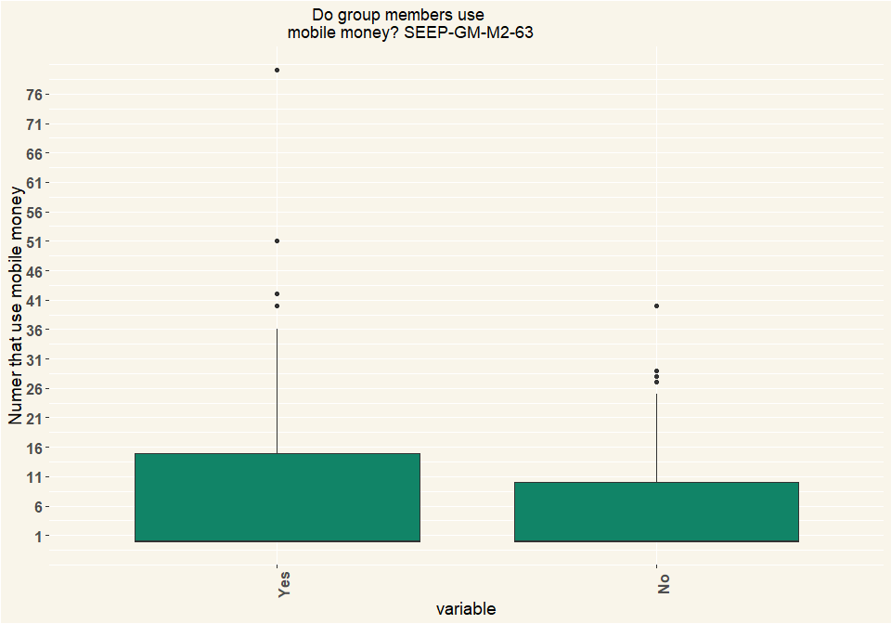

|  |  |
| --- | --- |
| Country | n |
| Mali | 156 |
| Uganda | 115 |

# Q64 What is mobile money used for by the members?

|  |  |  |
| --- | --- | --- |
| Value | Mali | Uganda |
| Saving | 7 | 42 |
| Sending money to group | 6 | 18 |
| Sending money to others | 12 | 64 |
| Receiving money from group | 7 | 16 |
| Receiving money from others | 41 | 74 |
| Getting a loan | 2 | 14 |
| Repaying a loan | NA | 10 |
| Other (specify) | 104 | 33 |
| Respondents | 156 | 115 |
| Value | Mali | Uganda |
| Saving | 0.0391 | 0.155 |
| Sending money to group | 0.0335 | 0.0664 |
| Sending money to others | 0.067 | 0.236 |
| Receiving money from group | 0.0391 | 0.059 |
| Receiving money from others | 0.229 | 0.273 |
| Getting a loan | 0.0112 | 0.0517 |
| Repaying a loan | NA | 0.0369 |
| Other (specify) | 0.581 | 0.122 |
| Percentage | 1 | 1 |

# 65 How many members have a smart phone that they can use when they need it?

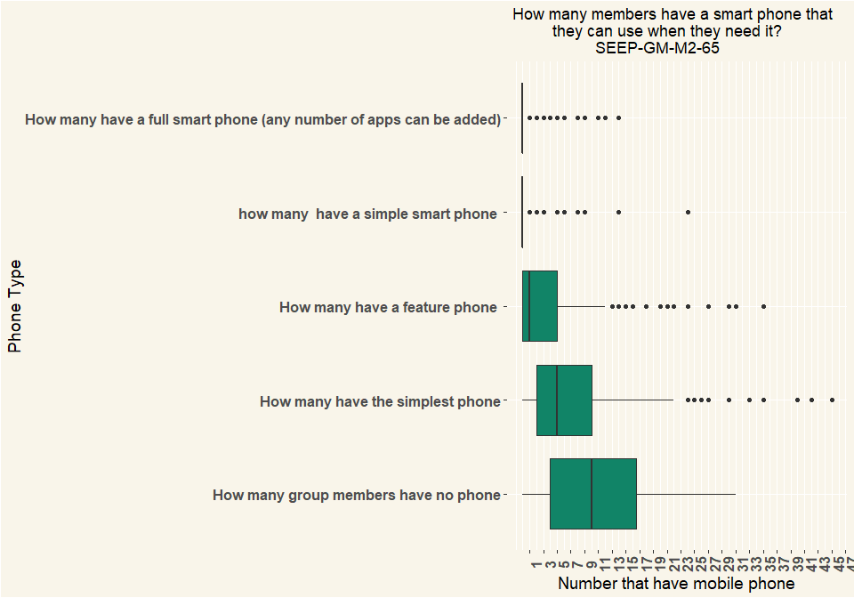

|  |  |
| --- | --- |
| Country | n |
| Mali | 156 |
| Uganda | 115 |

# 66 Does this VSLA group have relationships with the following type of organisations?

|  |  |  |
| --- | --- | --- |
| Value | Mali | Uganda |
| NGOs | 5 | 27 |
| CBOs | 7 | 6 |
| Government agencies | 1 | 5 |
| Religious institutions (mosque, church, …) | 2 | 4 |
| Political party | 1 | 5 |
| Private company | NA | 4 |
| None | 141 | 78 |
| Does not want to answer | NA | 1 |
| Respondents | 156 | 115 |
| Value | Mali | Uganda |
| NGOs | 0.0318 | 0.208 |
| CBOs | 0.0446 | 0.0462 |
| Government agencies | 0.00637 | 0.0385 |
| Religious institutions (mosque, church, …) | 0.0127 | 0.0308 |
| Political party | 0.00637 | 0.0385 |
| Private company | NA | 0.0308 |
| None | 0.898 | 0.6 |
| Does not want to answer | NA | 0.00769 |
| Percentage | 1 | 1 |

# 81 Do the members trade with each other / provide each other business / refer customers to each other?

|  |  |  |
| --- | --- | --- |
| Q_81 | Mali | Uganda |
| Yes | 58 | 39 |
| No | 97 | 75 |
| I don’t know | 1 | 1 |
| NA | 156 | 115 |
| Q_81 | Mali | Uganda |
| Yes | 0.372 | 0.339 |
| No | 0.622 | 0.652 |
| I don’t know | 0.00641 | 0.0087 |
| Percentage | 1 | 1 |

# 82 Does the group have any other form of innovation?

|  |  |  |
| --- | --- | --- |
| Q_82 | Mali | Uganda |
| Yes | 32 | 13 |
| No | 119 | 100 |
| I don’t know | 5 | 1 |
| I don’t want to answer | NA | 1 |
| Respondents | 156 | 115 |
| Q_82 | Mali | Uganda |
| Yes | 0.205 | 0.113 |
| No | 0.763 | 0.87 |
| I don’t know | 0.0321 | 0.0087 |
| I don’t want to answer | NA | 0.0087 |
| Percentage | 1 | 1 |

# 83 Are there women in local government (commune level)?

|  |  |  |
| --- | --- | --- |
| Q_83 | Mali | Uganda |
| Yes, several | 2 | 23 |
| Yes, one | 15 | 41 |
| No, none | 139 | 50 |
| Does not want to answer | NA | 1 |
| NA | 156 | 115 |
| Q_83 | Mali | Uganda |
| Yes, several | 0.0128 | 0.2 |
| Yes, one | 0.0962 | 0.357 |
| No, none | 0.891 | 0.435 |
| Does not want to answer | NA | 0.0087 |
| Percentage | 1 | 1 |

# 84 Are these elected women member of a VSLA savings group?

|  |  |  |
| --- | --- | --- |
| Q_84 | Mali | Uganda |
| Yes, all | 2 | 5 |
| Yes, some/one | NA | 13 |
| No, none | NA | 4 |
| I don’t know | NA | 1 |
| NA | 2 | 23 |
| Q_84 | Mali | Uganda |
| Yes, all | 1 | 0.217 |
| Yes, some/one | NA | 0.565 |
| No, none | NA | 0.174 |
| I don’t know | NA | 0.0435 |
| Percentage | 1 | 1 |

# 85 Is this elected woman member of a VSLA savings group that was formed by SaveUp or Banking on Change?

|  |  |  |
| --- | --- | --- |
| Q_85 | Mali | Uganda |
| Yes | 7 | 19 |
| No | 6 | 21 |
| I don’t know | 2 | 1 |
| NA | 15 | 41 |
| Q_85 | Mali | Uganda |
| Yes | 0.467 | 0.463 |
| No | 0.4 | 0.512 |
| I don’t know | 0.133 | 0.0244 |
| Percentage | 1 | 1 |

# 86 Do you think their/her election is related to VSLA saving group membership?

|  |  |  |
| --- | --- | --- |
| Q_86 | Mali | Uganda |
| Yes, due to savings groups she got elected | 7 | 35 |
| No, there is no connection | 7 | 23 |
| I don’t know | 3 | 6 |
| NA | 17 | 64 |
| Q_86 | Mali | Uganda |
| Yes, due to savings groups she got elected | 0.412 | 0.547 |
| No, there is no connection | 0.412 | 0.359 |
| I don’t know | 0.176 | 0.0938 |
| Percentage | 1 | 1 |

# 87 How did the VSLA savings group membership help the election?

|  |  |  |
| --- | --- | --- |
| value | Mali | Uganda |
| She/they got confidence because of the SFC savings group so dared to be nominated | 37 | 35 |
| She/they got skills because of the SFC groups, so knew how to convince voters | 5 | 40 |
| She/they got all the votes from the SFC savings groups | 4 | 27 |
| She/they learned in the SFC savings group that it is important women get elected | 11 | 12 |
| Other (specify) | 108 | 53 |
| NA | 156 | 115 |
| value | Mali | Uganda |
| She/they got confidence because of the SFC savings group so dared to be nominated | 0.224 | 0.21 |
| She/they got skills because of the SFC groups, so knew how to convince voters | 0.0303 | 0.24 |
| She/they got all the votes from the SFC savings groups | 0.0242 | 0.162 |
| She/they learned in the SFC savings group that it is important women get elected | 0.0667 | 0.0719 |
| Other (specify) | 0.655 | 0.317 |
| Percentage | 1 | 1 |

# 88 What are other motivations for joining VSLA group apart from savings?

|  |  |  |
| --- | --- | --- |
| value | Mali | Uganda |
| Social/being with friends | 145 | 88 |
| Learning skills | 83 | 79 |
| Organizing women to be strong together | 85 | 55 |
| Possibility to get loan | 85 | 85 |
| Possibility to do a business as a group | 63 | 26 |
| Selling goods to others | 0 | 7 |
| Other (specify) | 2 | 5 |
| Respondents | 156 | 115 |
| value | Mali | Uganda |
| Social/being with friends | 0.313 | 0.255 |
| Learning skills | 0.179 | 0.229 |
| Organizing women to be strong together | 0.184 | 0.159 |
| Possibility to get loan | 0.184 | 0.246 |
| Possibility to do a business as a group | 0.136 | 0.0754 |
| Selling goods to others | 0 | 0.0203 |
| Other (specify) | 0.00432 | 0.0145 |
| Percentage | 1 | 1 |

## Individual Questions Group Meeting 3

# Q51 Do you have a written constitution?

|  |  |  |
| --- | --- | --- |
| value | Mali | Uganda |
| Yes | 10 | 68 |
| No | 146 | 25 |
| Other (specify) | 0 | 4 |
| Respondents | 156 | 97 |
| value | Mali | Uganda |
| Yes | 0.0641 | 0.701 |
| No | 0.936 | 0.258 |
| Other (specify) | 0 | 0.0412 |
| Percentage | 1 | 1 |

# Q53 Since the group was formed, have you changed any of the rules, or adopted new rules?

|  |  |  |
| --- | --- | --- |
| value | Mali | Uganda |
| Yes | 105 | 49 |
| No | 51 | 48 |
| Respondents | 156 | 97 |
| value | Mali | Uganda |
| Yes | 0.673 | 0.505 |
| No | 0.327 | 0.495 |
| Percentage | 1 | 1 |

# Q54 Which rules were changed? Savings amount

|  |  |  |
| --- | --- | --- |
| value | Mali | Uganda |
| Share amount | 90 | 20 |
| Loan amount | 3 | 21 |
| Loan interest | 7 | 2 |
| Loan duration | 7 | 8 |
| Loan eligibility | 20 | 6 |
| Social Fund | 0 | 4 |
| Fine | 0 | 15 |
| Other (specify) | 27 | 15 |
| Respondents | 154 | 91 |
| value | Mali | Uganda |
| Share amount | 0.584 | 0.22 |
| Loan amount | 0.0195 | 0.231 |
| Loan interest | 0.0455 | 0.022 |
| Loan duration | 0.0455 | 0.0879 |
| Loan eligibility | 0.13 | 0.0659 |
| Social Fund | 0 | 0.044 |
| Fine | 0 | 0.165 |
| Other (specify) | 0.175 | 0.165 |
| Percentage | 1 | 1 |

# 57 What are the rules for loan disbursement?

|  |  |  |
| --- | --- | --- |
| value | Mali | Uganda |
| Maximum loan size | 54 | 44 |
| Maximum loan size based on savings amount | 46 | 60 |
| Maximum loan duration | 77 | 59 |
| Interest rate | 130 | 70 |
| Taking turns in taking loans | 34 | 15 |
| Whether loan use is productive | 5 | 11 |
| Other (specify) | 20 | 7 |
| Respondents | 156 | 97 |
| Value | Mali | Uganda |
| Maximum loan size | 0.148 | 0.165 |
| Maximum loan size based on savings amount | 0.126 | 0.226 |
| Maximum loan duration | 0.21 | 0.222 |
| Interest rate | 0.355 | 0.263 |
| Taking turns in taking loans | 0.0929 | 0.0564 |
| Whether loan use is productive | 0.0137 | 0.0414 |
| Other (specify) | 0.0546 | 0.0263 |
| Percentage | 1 | 1 |

# 58 Does your group sometimes not follow the rules? Can you give examples?

## [1] "Word cloud"

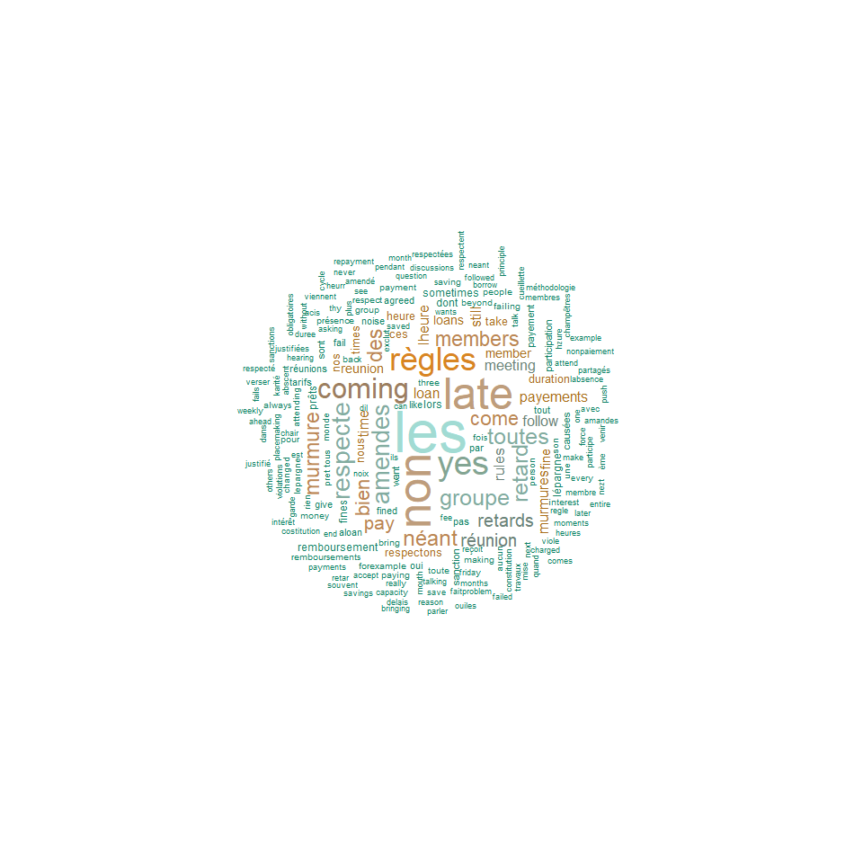

## [1] "2 word Phrase cloud"

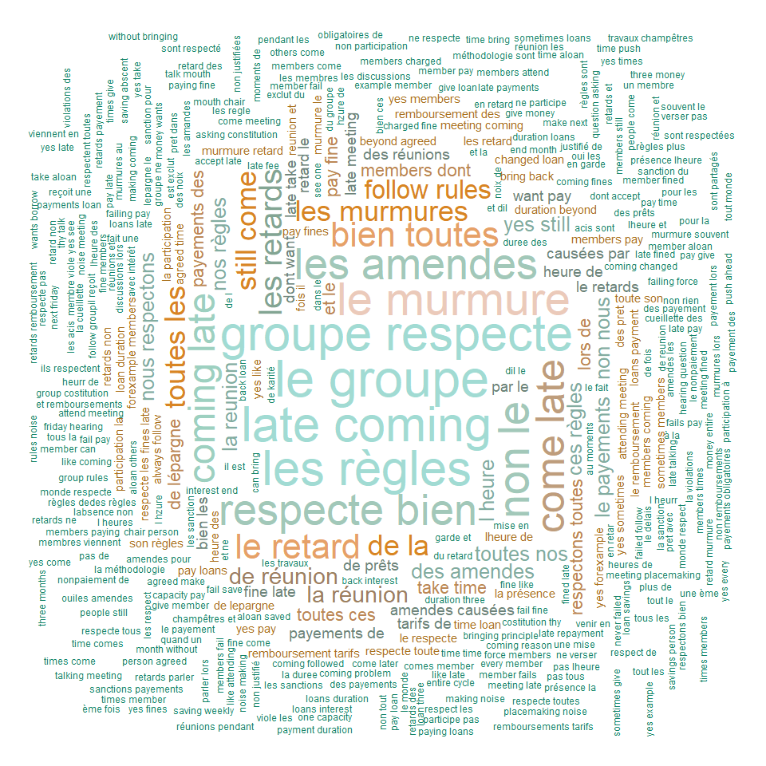

# 59 Does the group have a policy to fine members for infractions to the rules?

|  |  |  |
| --- | --- | --- |
| value | Mali | Uganda |
| Yes | 142 | 74 |
| No | 14 | 23 |
| Respondents | 156 | 97 |
| value | Mali | Uganda |
| Yes | 0.91 | 0.763 |
| No | 0.0897 | 0.237 |
| Percentage | 1 | 1 |

# 60 In your observation, is that policy observed?

|  |  |  |
| --- | --- | --- |
| value | Mali | Uganda |
| Yes, rigorously | 71 | 18 |
| Yes, some | 53 | 25 |
| A bit | 12 | 23 |
| Hardly at all | 5 | 3 |
| Not at all | 1 | 5 |
| Respondents | 142 | 74 |
| value | Mali | Uganda |
| Yes, rigorously | 0.5 | 0.243 |
| Yes, some | 0.373 | 0.338 |
| A bit | 0.0845 | 0.311 |
| Hardly at all | 0.0352 | 0.0405 |
| Not at all | 0.00704 | 0.0676 |
| Percentage | 1 | 1 |

# Q61 What are the acts that you saw fines being levied for?

|  |  |  |
| --- | --- | --- |
| value | Mali | Uganda |
| Talking during meeting | 114 | 26 |
| Late to meeting | 139 | 58 |
| Late repayment | 98 | 54 |
| Not saving | 131 | 32 |
| Arguments, saying bad things | 98 | 20 |
| Phone ringing during meeting | 27 | 6 |
| Other: | 1 | 7 |
| Respondents | 156 | 115 |
| value | Mali | Uganda |
| Talking during meeting | 0.188 | 0.128 |
| Late to meeting | 0.229 | 0.286 |
| Late repayment | 0.161 | 0.266 |
| Not saving | 0.215 | 0.158 |
| Arguments, saying bad things | 0.161 | 0.0985 |
| Phone ringing during meeting | 0.0444 | 0.0296 |
| Other: | 0.00164 | 0.0345 |
| Percentage | 1 | 1 |

# Q63 What is the maximum number of members the group would agree to expand to?

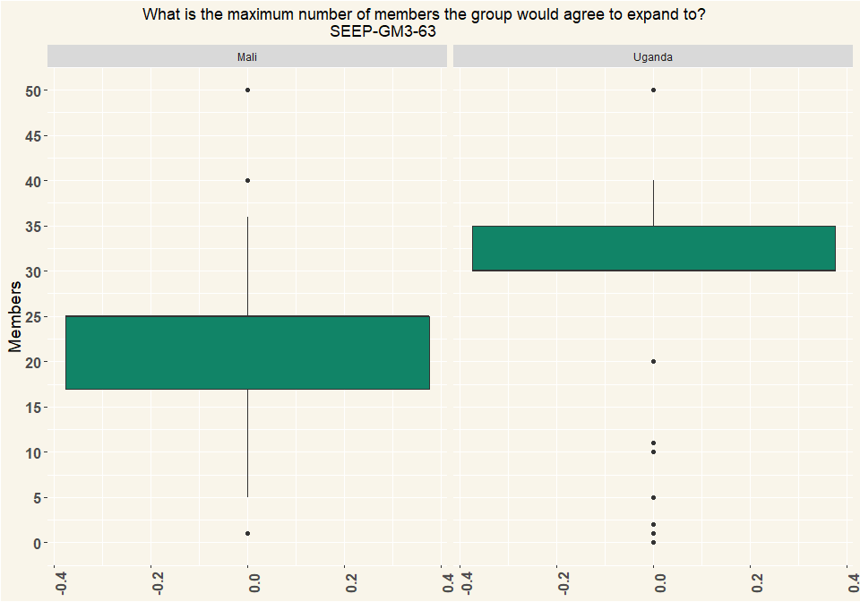

# Q64 What types of records does the group have?

|  |  |  |
| --- | --- | --- |
| value | Mali | Uganda |
| Central ledger | 107 | 79 |
| Passbooks | 18 | 84 |
| Other: | 31 | 3 |
| Respondents | 156 | 115 |
| value | Mali | Uganda |
| Central ledger | 0.686 | 0.476 |
| Passbooks | 0.115 | 0.506 |
| Other: | 0.199 | 0.0181 |
| Percentage | 1 | 1 |

# Q66 What is recorded?

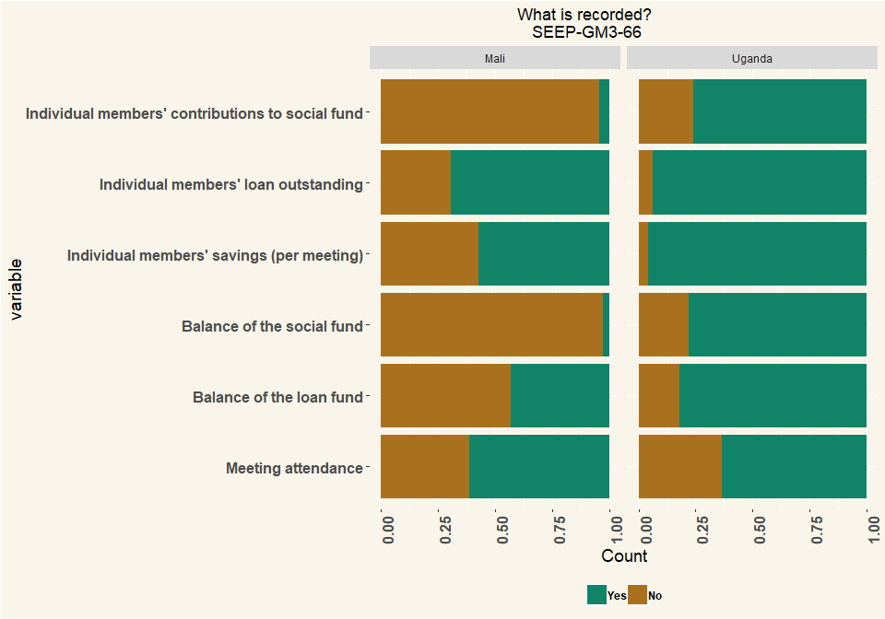

# 67 Is it possible to determine by simply looking at the records:

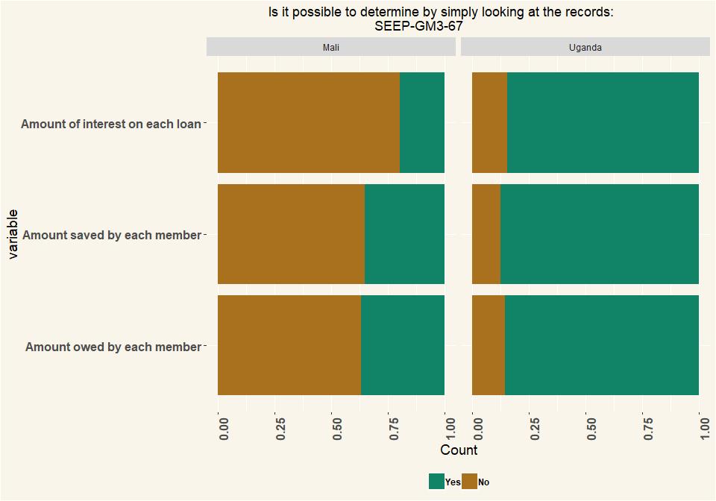

# Q68 Who keeps the passbooks between meetings?

|  |  |  |
| --- | --- | --- |
| value | Mali | Uganda |
| Members themselves keep it | 18 | 6 |
| Kept in the box or bag for money | 1 | 76 |
| Respondents | 19 | 82 |
| value | Mali | Uganda |
| Members themselves keep it | 0.947 | 0.0732 |
| Kept in the box or bag for money | 0.0526 | 0.927 |
| Percentage | 1 | 1 |

# Q69 Did any person at the group-meeting spot any errors in the bookkeeping, from this week or previous meetings

|  |  |  |
| --- | --- | --- |
| value | Mali | Uganda |
| Yes | 1 | 6 |
| No | 155 | 91 |
| NA | 156 | 97 |
| value | Mali | Uganda |
| Yes | 0.00641 | 0.0619 |
| No | 0.994 | 0.938 |
| NA | 1 | 1 |

#70 please describe the errors that you found?

## [1] "Word cloud"

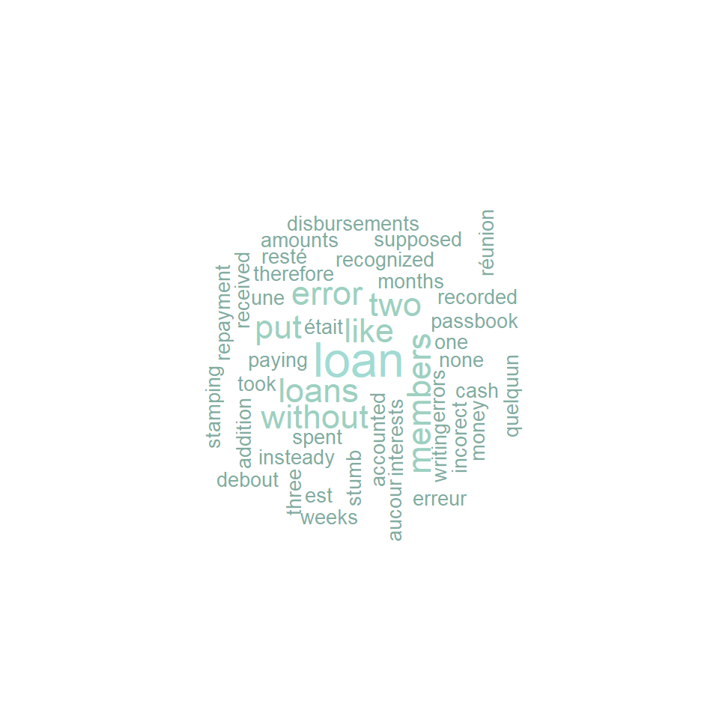

# Q71 Did you spot any errors in the bookkeeping when you looked at the records?

|  |  |  |
| --- | --- | --- |
| value | Mali | Uganda |
| Yes | 19 | 6 |
| No | 137 | 91 |
| Respondents | 156 | 97 |
| value | Mali | Uganda |
| Yes | 0.122 | 0.0619 |
| No | 0.878 | 0.938 |
| Percentage | 1 | 1 |

# Q72 How often does your group meet?

|  |  |  |
| --- | --- | --- |
| value | Mali | Uganda |
| Daily | 24 | 12 |
| Weekly | 132 | 84 |
| Every 2 weeks | 0 | 1 |
| Respondents | 156 | 97 |
| value | Mali | Uganda |
| Daily | 0.154 | 0.124 |
| Weekly | 0.846 | 0.866 |
| Every 2 weeks | 0 | 0.0103 |
| Percentage | 1 | 1 |

# Q73 Does your group have loan meetings and meetings where no loans are given (savings meetings)?

|  |  |  |
| --- | --- | --- |
| value | Mali | Uganda |
| Yes, only in some meetings can you get a loan,all meetings do savings | 24 | 12 |
| No, in all meetings we do both savings and loans | 132 | 84 |
| Other (specify) | 0 | 1 |
| Respondents | 156 | 97 |
| value | Mali | Uganda |
| Yes, only in some meetings can you get a loan,all meetings do savings | 0.154 | 0.124 |
| No, in all meetings we do both savings and loans | 0.846 | 0.866 |
| Other (specify) | 0 | 0.0103 |
| Percentage | 1 | 1 |

# Q74 How long does a group meeting typically last?

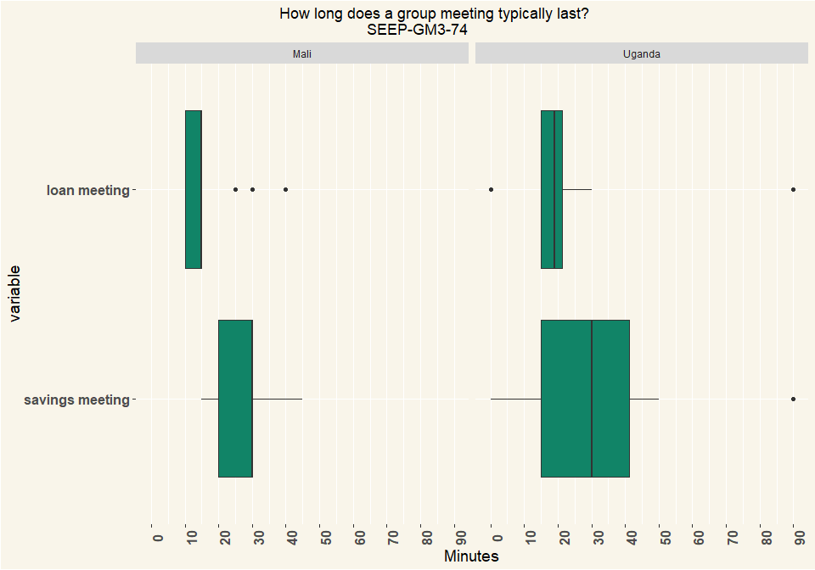

|  |  |
| --- | --- |
| Country | n |
| Mali | 25 |
| Uganda | 12 |

# Q85 What are other opportunities motivations for joining SFC (Uganda: VSLA) group apart from savings?

|  |  |  |
| --- | --- | --- |
| value | Mali | Uganda |
| Social/being with friends | 147 | 76 |
| Learning skills | 83 | 83 |
| Organizing women to be strong together | 81 | 53 |
| Possibility to get loan | 88 | 73 |
| Possibility to do a business as a group | 77 | 32 |
| Selling goods to others | 28 | 13 |
| Other (specify) | 0 | 5 |
| Respondents | 156 | 115 |
| value | Mali | Uganda |
| Social/being with friends | 0.292 | 0.227 |
| Learning skills | 0.165 | 0.248 |
| Organizing women to be strong together | 0.161 | 0.158 |
| Possibility to get loan | 0.175 | 0.218 |
| Possibility to do a business as a group | 0.153 | 0.0955 |
| Selling goods to others | 0.0556 | 0.0388 |
| Other (specify) | 0 | 0.0149 |
| Percentage | 1 | 1 |

# Q86 How have members livelihood changed as a result of being an SFC (Uganda VSLA) member? How?

|  |  |  |
| --- | --- | --- |
| value | Mali | Uganda |
| They have more income | 134 | 80 |
| They have less income | 10 | 5 |
| They have more possessions | 103 | 58 |
| They have less possessions | 5 | 2 |
| They have more businesses | 80 | 36 |
| They have smoother finances | 100 | 45 |
| They have more spiky finances | 17 | 2 |
| Other (specify) | 1 | 6 |
| Respondents | 156 | 115 |
| value | Mali | Uganda |
| They have more income | 0.298 | 0.342 |
| They have less income | 0.0222 | 0.0214 |
| They have more possessions | 0.229 | 0.248 |
| They have less possessions | 0.0111 | 0.00855 |
| They have more businesses | 0.178 | 0.154 |
| They have smoother finances | 0.222 | 0.192 |
| They have more spiky finances | 0.0378 | 0.00855 |
| Other (specify) | 0.00222 | 0.0256 |
| Percentage | 1 | 1 |

# Q87 Are VSLAs used as a platform for other interventions in the communities? What are they?

|  |  |  |
| --- | --- | --- |
| value | Mali | Uganda |
| For selling/buying to each other | 108 | 29 |
| For selling in bulk | 61 | 12 |
| For joint business | 66 | 20 |
| For learning economic skills | 100 | 65 |
| For learning about nutritioin | 60 | 25 |
| For learning about health | 59 | 36 |
| For learning about finance | 89 | 61 |
| For organizing politically | 50 | 22 |
| For fighting for women’s rights | 64 | 21 |
| Other (specify) | 1 | 5 |
| Respondents | 156 | 115 |
| value | Mali | Uganda |
| For selling/buying to each other | 0.164 | 0.098 |
| For selling in bulk | 0.0927 | 0.0405 |
| For joint business | 0.1 | 0.0676 |
| For learning economic skills | 0.152 | 0.22 |
| For learning about nutritioin | 0.0912 | 0.0845 |
| For learning about health | 0.0897 | 0.122 |
| For learning about finance | 0.135 | 0.206 |
| For organizing politically | 0.076 | 0.0743 |
| For fighting for women’s rights | 0.0973 | 0.0709 |
| Other (specify) | 0.00152 | 0.0169 |
| Percentage | 1 | 1 |

# Q88 How does to the community view members of SFC (Uganda: VSLA)?

## word freq  
## bien bien 47  
## des des 39  
## les les 37  
## par par 33  
## bonne bonne 27  
## group group 24  
## communauté communauté 23  
## membres membres 22  
## women women 18  
## ont ont 18

## [1] "Word cloud"

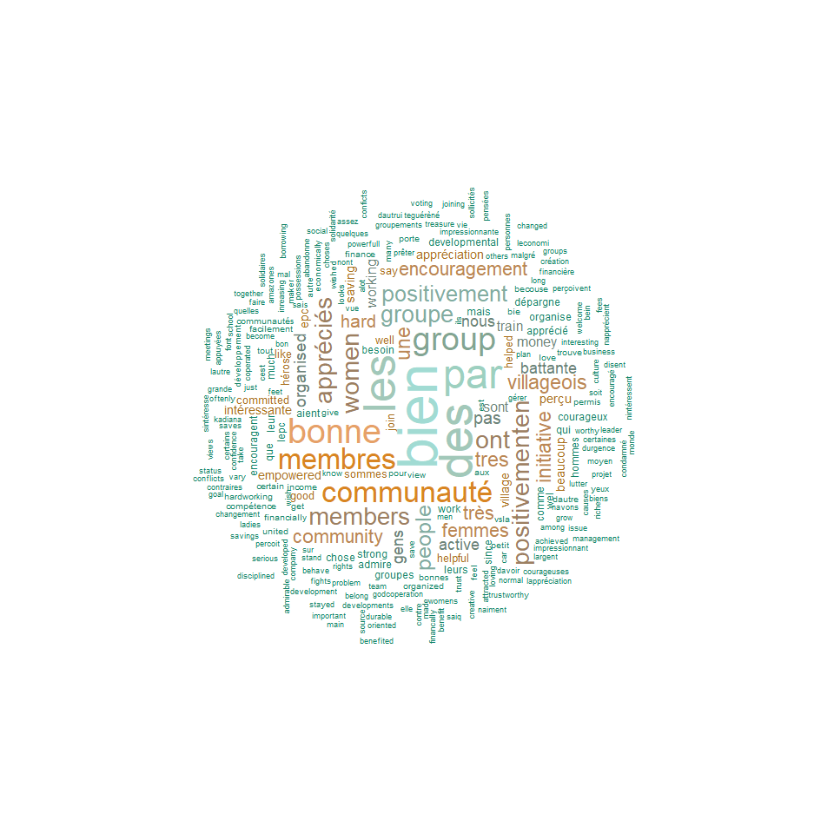

## [1] "2 word Phrase cloud"

 